Friday, April 23– 2:30 p.m.
Organizational Update

Good afternoon,
We are happy to report that there are no Villages within our organization in outbreak status. We do have some locations that continue to monitor closely with cases identified among a low number of team members, but local Public Health units have determined full outbreak measures are not required.
We remind everyone that the definition of Confirmed Outbreak, according to Public Health guidance, is: two or more lab-confirmed cases in residents/staff/visitors in a long-term care home, with an epidemiological link, within a 14-day period, where at least one case likely acquired the infection in the home.
The definition of a suspect outbreak refers to a single, lab-confirmed COVID-19 case in a resident. As always, local public health units have the discretion to declare an outbreak and end an outbreak. In all of our Villages, our teams continue to monitor everyone closely and regular, rapid testing is underway to ensure that any possible case is identified quickly and appropriate Infection Prevention and Control measures cane be put in place.
As always, we thank everyone for their continued efforts to stem the tide of this third wave in our communities.
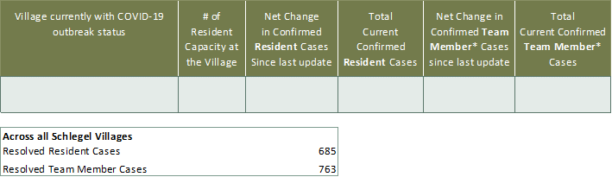
Villages with Outbreak Status

*Team member reporting may include “essential caregivers,” agency staff, contracted service providers (such as fire inspectors or general maintenance service people), as well as care providers contracted by Local Health Integration Units.

