Monday, April 26– 2:00 p.m.
Organizational Update

Good afternoon,
As happy as we were to have a blank chart on our report Friday, we are fully aware of the continuing rate of community spread across the province. We do have locations in “suspect outbreak” still, meaning a low number of cases with minimal risk to residents and team members, and we have placed the Village at University Gates Long-Term Care Home on our chart. With three team member cases confirmed there, Public Health has placed the home in outbreak and full protocols are in place. We thank everyone there for their efforts to minimize any risk of spread.

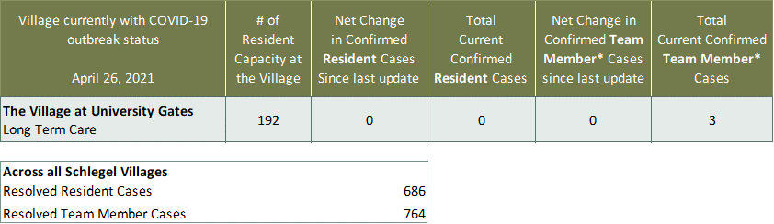
Villages with Outbreak Status

*Team member reporting may include “essential caregivers,” agency staff, contracted service providers (such as fire inspectors or general maintenance service people), as well as care providers contracted by Local Health Integration Units.

