Friday, April 30– 3:30 p.m.
Organizational Update

Good afternoon,
While we do have some locations considered to be in “suspect outbreak” or “enhanced monitoring” in the language of their respective health units, these are based on a small number of identified, low risk cases. Only The Village at University Gates Long-Term Care is considered to be in outbreak; we are grateful the case numbers remain steady and we thank the team there for their efforts to minimize any potential spread. All of our teams continue to show their compassion and dedication in all they do to support residents, even as the province continues to struggle with the capacity of the acute care system to support the record numbers of sick people in our hospitals.
While our teams and residents give so much to support each other, we know a vast number of them are deeply concerned for loved ones here and abroad that are facing the devastating impact of the virus still today. Cultural diversity in our Villages is something we honour and cherish, and we wanted to share a message from our President and CEO James Schlegel, recognizing the impact this virus is having on family, friends and neighbours around the world. Click here to read the message.

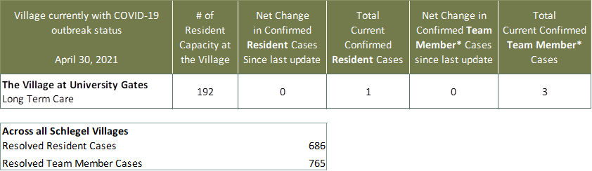
Villages with Outbreak Status

*Team member reporting may include “essential caregivers,” agency staff, contracted service providers (such as fire inspectors or general maintenance service people), as well as care providers contracted by Local Health Integration Units.

