Friday, February 12 – 2:00 p.m.
Organizational Update

Good afternoon,
Since our last update, the team from The Village at St. Clair is mourning the passing of two residents who had previously tested positive for COVID-19. Both of these residents were no longer actively positive for the virus, but this makes no difference in terms of the sorrow the team and the families are feeling. Those who serve the most vulnerable members of our community in long-term care or retirement settings know that the loss of people they’ve grown to care for is an eventual reality, but it is never easy. Our hearts are with the team and the families today.
The overall trend in resolved cases in several Villages is a hopeful sign, though we did see one new resident case at St. Clair and one in Long-Term Care at The Village of Winston Park. There are two new team member cases on our chart, as well, but several more resolved and we know the Villages are eager to welcome these team members back. The teams in all Villages continue to work tirelessly to follow all Infection Prevention and Control Protocols in support of the residents they serve, and we commend them for their consistent dedication as we enter the 11th month of this pandemic.
This weekend, with Valentine’s Day and Family Day back-to-back, we know the separation loved ones feel will seem even more pronounced. Whether through creative, safely-designed events under Public Health protocols or with special treats and meals or virtual visits, our teams are preparing to make these days as meaningful as possible for the residents, with love in their hearts.
We wish for our entire community the opportunity to find joy in the weekend, despite the challenges we have seen, and we thank everyone for the ongoing support and encouragement. Our next report will be in Wednesday, but please be assured that Villages will reach out directly to families should and updates be required earlier.
Take care.

Please note: Chart formatting
The number in the first column of the chart represents the full capacity of each Village in terms of resident numbers.
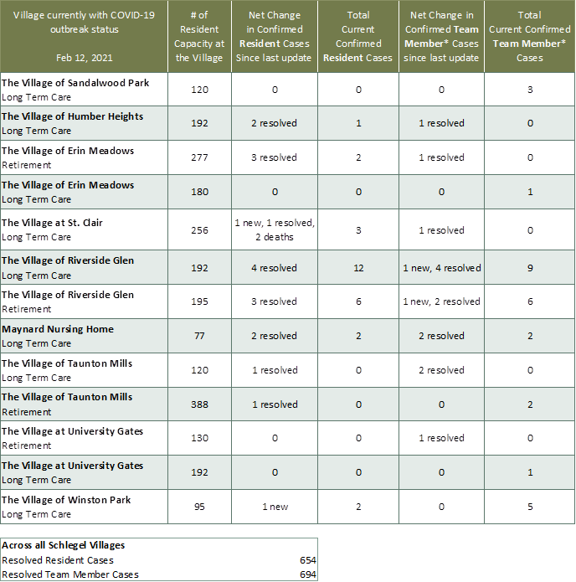

*Team member reporting may include “essential caregivers,” agency staff, contracted service providers (such as fire inspectors or general maintenance service people), as well as care providers contracted by Local Health Integration Units.

