Wednesday, February 17 – 3:30 p.m.
Organizational Update

Good afternoon,
Since our last report before the Family Day Weekend, we have seen a number of hopeful signs, with three Villages removed from outbreak status and number of resolved cases elsewhere. This hopeful news, however, is eclipsed by the sorrow two Villages have faced with the loss of residents, each of whom held a special place in their community and had previously tested positive for COVID-19. The Village at St. Clair said goodbye to one resident while The Village of Riverside Glen Long-Term Care lost five residents. Our entire organization stands in solidary as these teams and loved one are facing grief in this moment.
With 19 Villages across the province, some of which serve both Long-Term Care and Retirement, we do want to focus on the hopeful news. As of this morning, both Retirement and Long-Term Care at The Village of Erin Meadows have no active cases, as is the case at Sandalwood Park. The Village of Taunton Mills Long-Term Care has been resolved, as has both sides of The Village at University Gates. There are several team members able to return to work in affected Villages and the vaccinations continue, with nearly 70 percent of all residents inoculated with both doses of the vaccine and more than 90 percent with their first.
We continue to reinforce the need for everyone connected to our Villages to remain vigilant as we look to protect not only our Villages, but all of our neighbours. With the concerted efforts of many people coming together, we are seeing progress on the horizon and for that, we thank you.

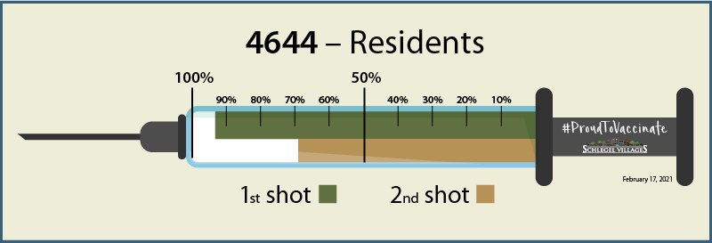
Please note: Chart formatting
The number in the first column of the chart represents the full capacity of each Village in terms of resident numbers.
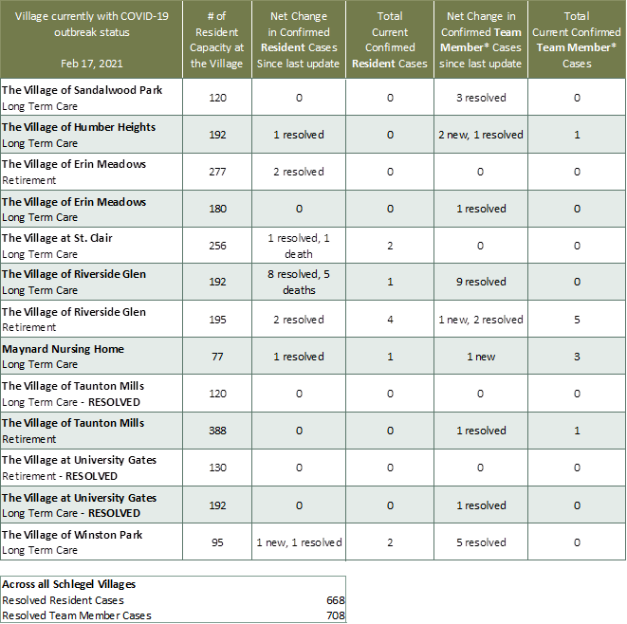

*Team member reporting may include “essential caregivers,” agency staff, contracted service providers (such as fire inspectors or general maintenance service people), as well as care providers contracted by Local Health Integration Units.

