Wednesday, February 10 – 2:00 p.m.
Organizational Update

Good afternoon,
While we are encouraged by stability in most of our affected Villages and the number of resolved cases show a hopeful trend, this news is overshadowed by sorrow as we must report the loss of three residents who had all tested positive for COVID-19. That each person was already facing serious illness prior to diagnosis matters not, for each loss, no matter the cause, is felt deeply by our teams and loved ones who are still faced with grief, nonetheless.
Two of these residents called The Village of Riverside Glen Home while the third lived in The Village at St. Clair; our thoughts are with both of those communities, while they are facing such difficulty. There are some additional positive cases the team at Riverside Glen retirement is managing, but elsewhere the numbers continue to trend in the right direction. We were pleased to pull The Village of Winston Park Retirement Home off of our chart, as the outbreak there has been resovled, though they will continue to be in enhanced monitoring in collaboration with Public Health.
Our vaccination numbers also continue to trend in the right direction with rising numbers of residents and team members receiving second doses and first doses of the vaccines. We look forward to increased supplies across the province in order to be sure more of the wider public has access so we can truly see the rates of transmissions fall.

Please note: Chart formatting
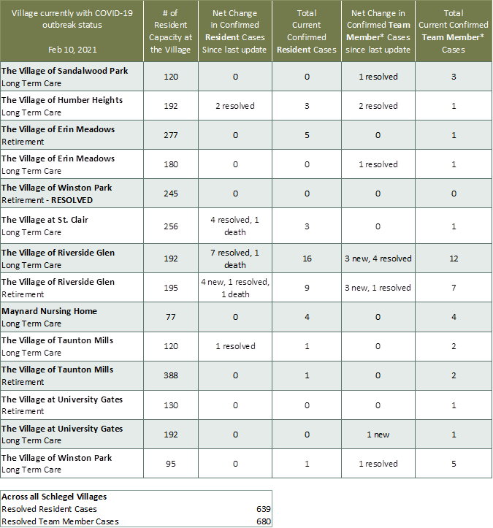
The number in the first column of the chart represents the full capacity of each Village in terms of resident numbers.

*Team member reporting may include “essential caregivers,” agency staff, contracted service providers (such as fire inspectors or general maintenance service people), as well as care providers contracted by Local Health Integration Units.

