Monday, February 22 – 2:00 p.m.
Organizational Update

Good afternoon,
We had another fairly stable weekend throughout our affected villages, though one new positive case at Maynard Nursing Home has emerged and the team there will be working closely with Public Health to determine possible tracing. There are several resolved cases and we are very happy for the team and residents in retirement in the Village of Erin Meadows, which joined the long-term care neighbourhoods there in being resolved of outbreak.
Several other locations are expected to be cleared of outbreak status soon, and we look forward to sharing that news. In terms of our Vaccination numbers, we are slowly seeing team member numbers rising and we know that, depending on location and public health unit, essential caregivers are also able to get on the vaccination schedule. This is at the discretion of each health unit and Villages will communicate this information directly.
We have also heard from families wondering if restrictions will be lifted once retirement home and long-term care residents have been vaccinated. We certainly hope this will be the case but, at this time, there is no change to the restrictions mandated by Ontario’s Chief Medical Officer of Health based on vaccinations.
Even as we see hopeful signs of progress across the province, we will continue to do all we can to support and protect the well-being of those we are privileged to serve.
Thank you.

Please note: Chart formatting
The number in the first column of the chart represents the full capacity of each Village in terms of resident numbers.
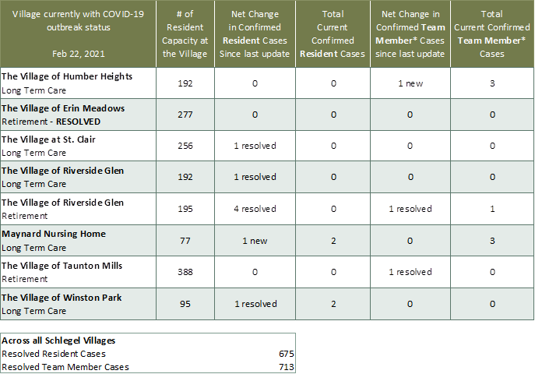

*Team member reporting may include “essential caregivers,” agency staff, contracted service providers (such as fire inspectors or general maintenance service people), as well as care providers contracted by Local Health Integration Units.

