Wednesday, February 24 – 3:00 p.m.
Organizational Update

Good afternoon,
We would first like to correct an error in our last report, where we indicated that Maynard Nursing Home had an additional team member case. This was a reporting error so there are still only two active team member cases connected to the small Village, and we are happy to note that the final two remaining resident cases were resolved. Our apologies for any confusion.
As of last night, three team members were confirmed as positive at Fairview Nursing Home, with one of those cases identified as positive for the B117 variant, first identified in the United Kingdom. All residents are doing fine and there are no signs of any symptoms, but the team will be monitoring everyone closely in collaboration with Public Health. We will also mention that am essential caregiver connected to The Village of Erin Meadows Long-Term Care has also tested positive. As the risk of outbreak is deemed low, Public Health has not declared a full outbreak at this time, though the team will be monitoring everyone closely.
Beyond that news, we are happy to report that the outbreak at The Village of Riverside Glen Long-Term Care has been rescinded and we are hopeful the retirement home there, with no active cases, will follow suit soon. Several other locations also remain clear of COVID-19 and we are expecting more outbreak resolutions soon.
Overall, we continue to see hopeful trends in communities across the province, but the news we shared today reminds us all that the virus and the variants of concern are still active and we all have a part to play in protecting those who are most vulnerable. The Vaccination program, which we are thankful is again ramping up in Ontario, will continue to have a strong impact. Please click here for message from our CEO, James Schlegel, related to gratitude for the vaccines and the hope they represent.
Thank you.

Please note: Chart formatting
The number in the first column of the chart represents the full capacity of each Village in terms of resident numbers.
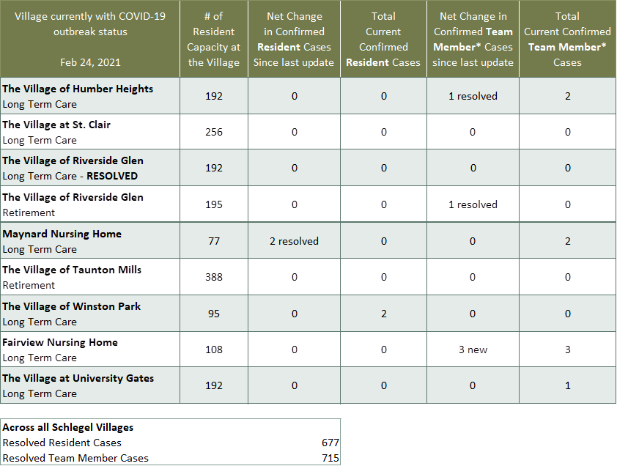

*Team member reporting may include “essential caregivers,” agency staff, contracted service providers (such as fire inspectors or general maintenance service people), as well as care providers contracted by Local Health Integration Units.

