Wednesday, July 1 – 12:00 p.m.
Organizational Update

Good afternoon,

We are grateful on a bright and sunny Canada Day to announce that both The Village of Aspen Lake in Windsor and Fairview Nursing Home in Toronto have been declared free of COVID-19 and they are no longer in outbreak. Any potential risk was mitigated through the teams’ hard work and with the cooperation of the residents. We thank every one for their patience and support and we’re hopeful we will see more resolved cases soon elsewhere. The teams will have connected with families and I know everyone looks forward to resuming visitation. Thank you for understanding the importance of all precautions as this new phase opens up.

We must note that The Village of Humber Heights Long-term Care, which was pulled out of outbreak last week though Public Health had not resolved all cases, is back on our chart. As the team monitors things closely, we are confident in their ability to manage the risks with the knowledge gained since the start of the pandemic.

On this, an important day of reflection, we are deeply grateful to live where we do and serve people across the province. These have been difficult times and we remember those who have been most harshly hit during the past three months with sorrow, but we think also of the way Canadians have come together to help one another since March. There is pride to be found in that and we speak for all of Schlegel Villages when we say we are proud to serve.

Thank you.

Please note: Chart formatting
*The number in the first column of the chart represents the full capacity of each Village in terms of resident numbers.

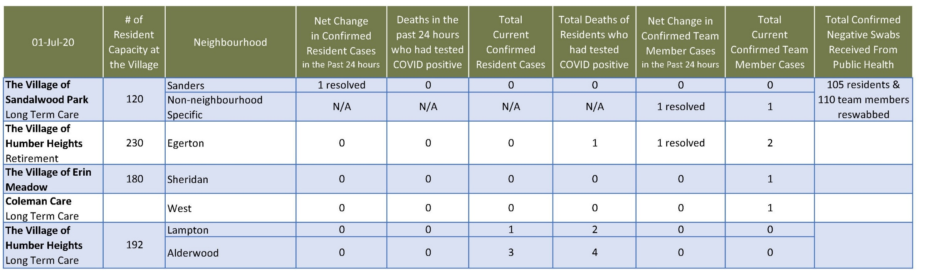
Total Resolved Cases Across Schlegel Villages as of Today:
Residents: 181
Team members: 130

