Friday, July 16 - 4:00 p.m.
Organizational Update

Good afternoon,
The team at The Village of Tansley Woods Long-Term Care Home and everyone supporting from across our organization is thinking of the loved ones of a resident there who had tested positive for COVID-19 and passed away last evening.
The challenge of managing the presence of the delta variant is complex and the team continues to work closely with Public Health to be sure they are following every protocol. While the outbreak remains contained to two neighbourhoods, and two additional residents and one team member have been resolved, unfortunately three additional residents have been confirmed positive.
We must be extremely careful in protecting the health information and privacy of our residents and team members, but we can say that of all the people who have tested positive for COVID-19, bearing in mind that we do know the delta variant has been identified in this current outbreak, two residents and one team member were unvaccinated. In all other cases, residents and team members were fully immunized. We can say those who did experience serious symptoms did have serious underlying health conditions prior to the outbreak. The majority of those affected have experienced nothing more than minor symptoms, though this fact does not diminish the need for strong Infection Prevention and Control measures, and we acknowledge the effort of the team and caregivers at Tansley Woods for their dedication in supporting residents and each other during this difficult time.
We are pleased to say a Vaccine Clinic has been finalized at Tansley Woods this coming Thursday in collaboration with the Ministry for Seniors and Accessibility, and we look forward to welcoming team members, any remaining residents and caregivers.
Thank you

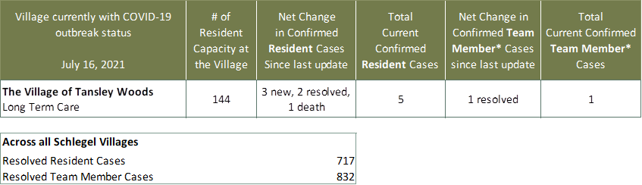
Villages with Outbreak Status
*Team member reporting may include “essential caregivers,” agency staff, contracted service providers (such as fire inspectors or general maintenance service people), as well as care providers contracted by Local Health Integration Units.

