Monday, July 19 - 2:00 p.m.
Organizational Update

Good afternoon,
We have no new cases to report in any of our Villages and we were pleased to see the final team member case resolved at The Village of Tansley Woods, leaving five active resident cases.
As we have mentioned, The Village of Tansley Woods is hosting a Pfizer Vaccine clinic this Thursday beginning at 9 am. The clinic will be held outside in the parking lot and all safety precautions will be in place. This clinic is open to the public and we encourage anyone who is interested to e-mail pennie.pryce-jones@schlegelvillages.com with their information, including date of birth and whether it is a first or second dose.
Thank you.

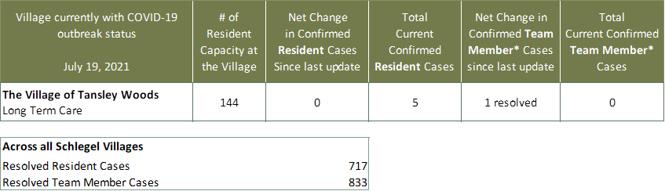
Villages with Outbreak Status
*Team member reporting may include “essential caregivers,” agency staff, contracted service providers (such as fire inspectors or general maintenance service people), as well as care providers contracted by Local Health Integration Units.

