**Wednesday, July 21st– 3:00 p.m.**

Organizational Update

Good afternoon,

We would like to acknowledge the tremendous work being done by the team at the Village of Tansley Woods in their ongoing efforts to combat the Outbreak in the Village along with the support and patience of residents and family members/loved ones. Since our last update we have had three new resident positive cases and one additional team member test positive. These cases are in the same affected areas as in the past so no new neighbourhood has been affected.

This is the final reminder that the Village of Tansley Woods is hosting a Pfizer Vaccine clinic tomorrow beginning at 9 am. The clinic will be held outside in the parking lot and all safety precautions will be in place. This clinic is open to the public and we encourage anyone who is interested to e-mail [pennie.pryce-jones@schlegelvillages.com](mailto:pennie.pryce-jones@schlegelvillages.com) with their information, including date of birth and whether it is a first or second dose.

We would also like to share the following link to a story concerning research efforts related to COVID-19 and vaccination efficacy for you to read: <https://schlegelvillages.com/news/combined-efforts-covid-research>. Schlegel Villages is proud to support the work of researchers and investigators as we collectively battle this terrible virus and seek answers for a hopeful tomorrow.

**Villages with Outbreak Status**

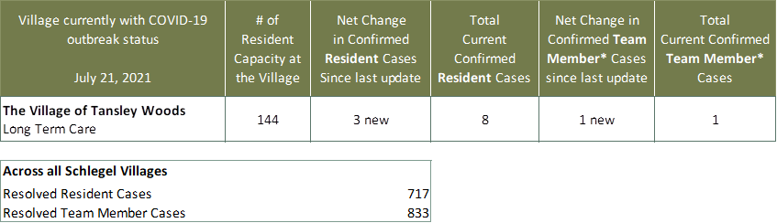

*Team member reporting may include “essential caregivers,” agency staff, contracted service providers (such as fire inspectors or general maintenance service people), as well as care providers contracted by Local Health Integration Units.