Friday, July 23 - 2:30 p.m.
Organizational Update

Good afternoon,
We have no changes in status to report today in any of our Villages, with The Village at Tansley Woods maintaining holding the same numbers as our last report. We do want to make special mention of the efforts the team at Tansley Woods put towards the successful Vaccine Clinic it hosted yesterday. With the support of our partners with the Ministry for Seniors and Accessibility, the Village welcomed just over 200 people – team members, residents, caregivers and neighbours from the wider community.
It truly does take a Village to care and we offer gratitude to our many partners, neighbours and friends for the continued support and encouragement.

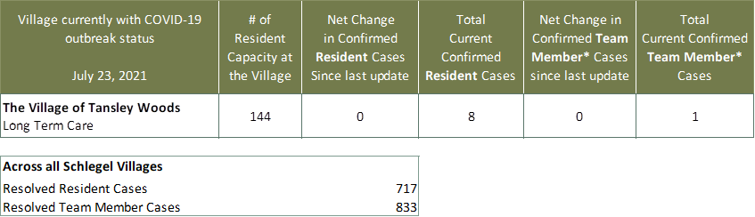
Villages with Outbreak Status
*Team member reporting may include “essential caregivers,” agency staff, contracted service providers (such as fire inspectors or general maintenance service people), as well as care providers contracted by Local Health Integration Units.

