Monday, July 26 - 4:00 p.m.
Organizational Update

Good afternoon,
Our community is feeling the weight of loss as we acknowledge the passing of a resident from the Village of Tansley Woods over the weekend. The relationships we forge together are the heart of our communities, so it is never easy to say goodbye and our thoughts are with loved ones and team members who are facing this grief today. The resident who passed had previously tested positive for COVID-19.
At this time, there are no active team member cases in The Village and a total of five active resident cases. Testing is underway again for team members and residents in the two affected neighbourhoods and we will update any changes on Wednesday.
Thank you.

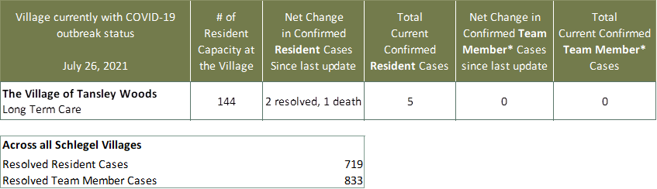
Villages with Outbreak Status
*Team member reporting may include “essential caregivers,” agency staff, contracted service providers (such as fire inspectors or general maintenance service people), as well as care providers contracted by Local Health Integration Units.

