**Monday, July 28 - 2:00 p.m.**

Organizational Update

The Village of Tansley Woods Long-Term Care Home has seen an additional resident test positive after 85 tests were conducted Monday among team members and residents in the two affected neighbourhoods. All other test results returned negative and the team continues to work closely with Public Health officials to identify any possible contact tracing in light of this additional case.

This week we mark 500 days since the state of emergency was declared in Ontario as a result of the COVID-19 pandemic, and we take time to honour the dedication, commitment and sacrifices our teams, residents, families and partners have displayed and made these past months. All facets of the healthcare system have shown the face of resiliency, even if at times it has felt false for those on the front lines of care, for the burden has been great and the sorrow real. In the wider community, it feels as though life is returning to normal but for the caregivers of those most vulnerable, fear, worry and trauma remain. Our commitment to the emotional well being of our teams and leaders remains strong and we encourage everyone feeling the pressure of the pandemic to focus on their own well being. Please visit [Wellness Together Canada](https://wellnesstogether.ca/en-CA) as a starting point.

Thank you.

**\*Villages with Outbreak Status**

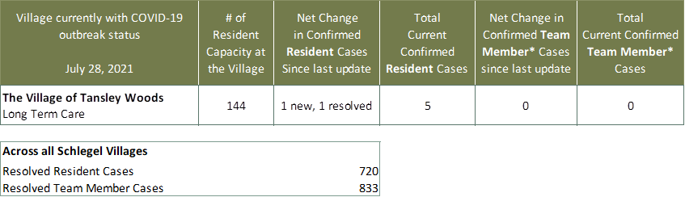

*Team member reporting may include “essential caregivers,” agency staff, contracted service providers (such as fire inspectors or general maintenance service people), as well as care providers contracted by Local Health Integration Units.