Thursday, July 2 – 1:00 p.m.
Organizational Update

Good Afternoon,

We continue to see numbers flatten as our teams in our four remaining affected Villages work through what we hope will be the final stages of outbreak protocols. The number of negative tests that continue to return is reason for optimism, and ongoing testing is one of the key aspects of our knowledge and understanding moving forward.

We want to thank all the team members for taking part in this ongoing process, and we also offer gratitude for the family members who are going through the testing process prior to their visits with loved ones. We know this presents a challenge for many, but as part of the provincial mandates, it is a necessary precaution for infection prevention.

On that note, we thank every Village for once again working through our internal Infection Prevention and Control (IPAC) assessments. These are currently underway again in all Villages, and they are an important tool to help teams prioritize the many angles of safe practice to protect everyone in the Village community. Last month’s assessments revealed many points of pride in terms of the quality of every IPAC effort, and we look forward to the results of the current round of assessments.

Please note: Chart formatting
*The number in the first column of the chart represents the full capacity of each Village in terms of resident numbers.
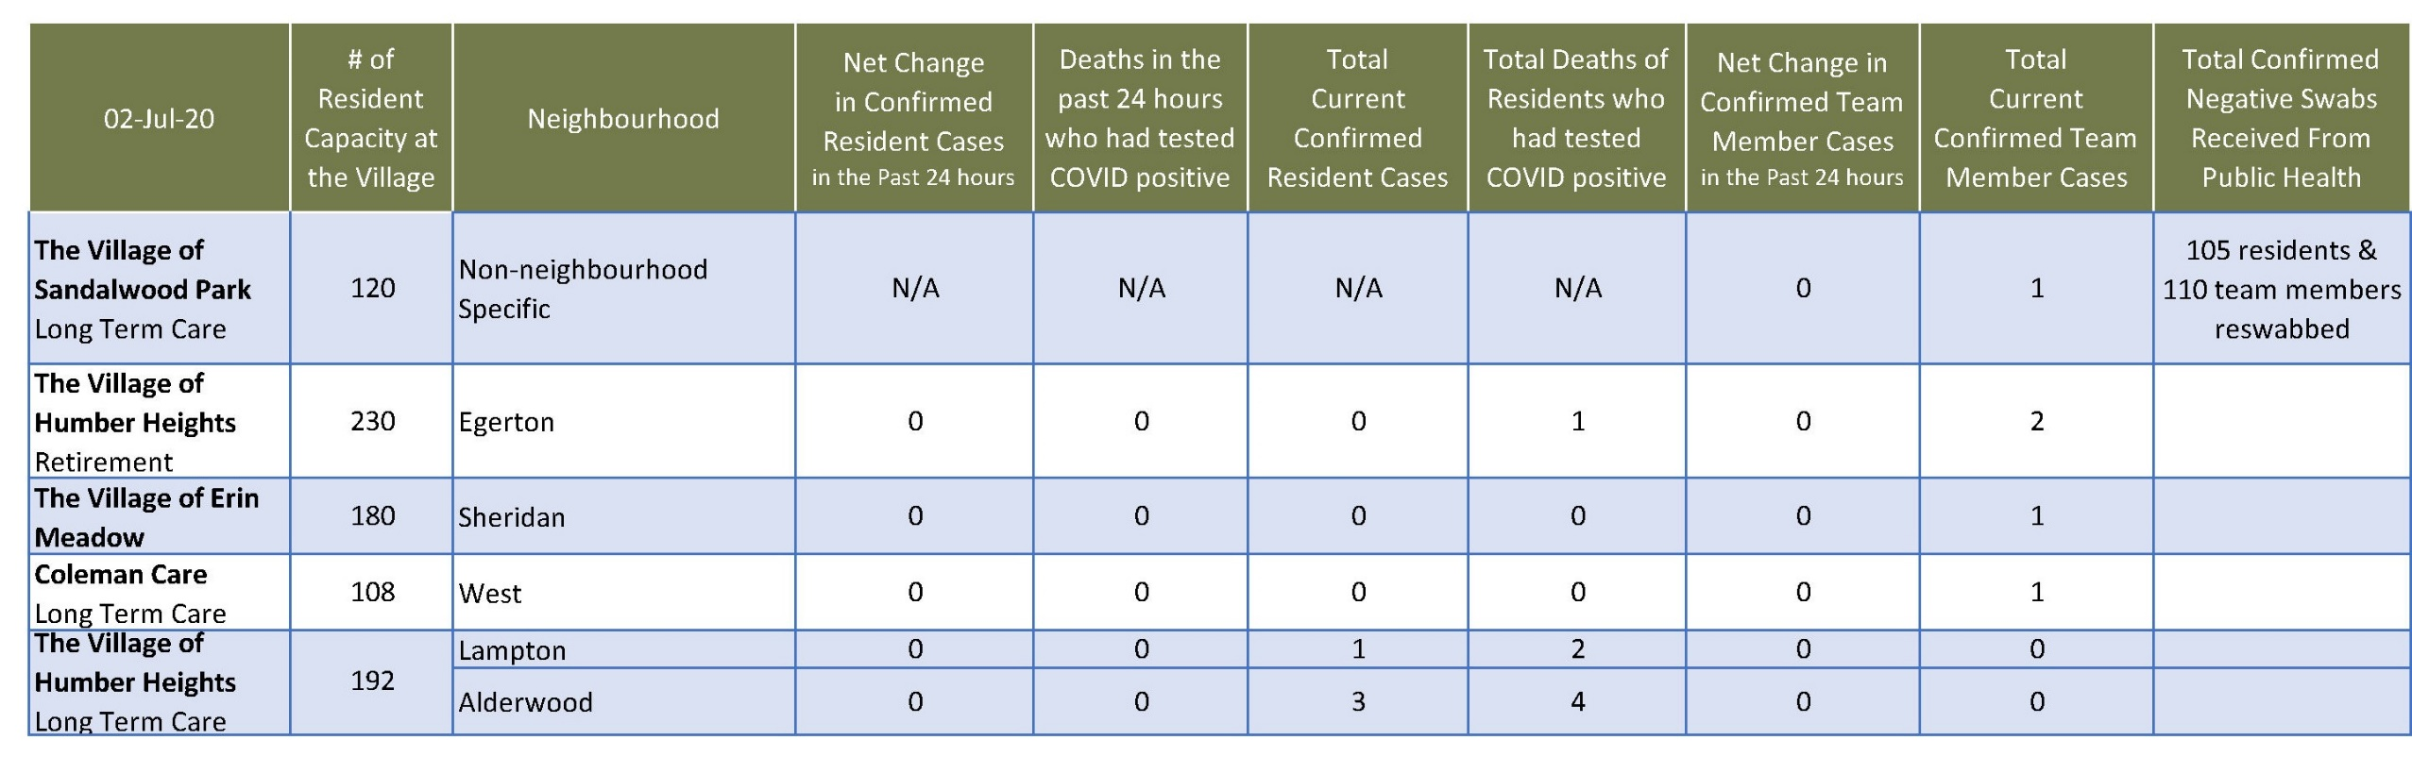
Total Resolved Cases Across Schlegel Villages as of Today:
Residents: 181
Team members: 130

