**Friday, July 30 - 3:00 p.m.**

Organizational Update

Good afternoon,

Since our last report, the Village of Tansley Woods has seen four more resident cases classed as resolved, leaving only one active case on the Bronte neighbourhood. Our gratitude flows to the team there for the continued efforts to support residents and each other while working to resolve the outbreak.

As we mentioned in our last report, we acknowledge the efforts of all of our teams and the patience and understanding of our residents, families and partners through all of these many months under the shadow of COVID-19. The reality is, as we open up more and we see the province as a whole moving towards a sense of normalcy, many of our team members and residents remain fearful of a resurgence. We thought we’d share a story that speaks to the way so many of us are feeling as we reflect on the great challenge of the past while looking to the future with a cautious sense of hope.[Click here](https://schlegelvillages.com/news/perseverance-courage-and-determination-through-500-days-covid) to see the story.

Lastly, in light of the Civic Holiday Weekend, our next update will be on Wednesday, August 4.

Thank you.

**\*Villages with Outbreak Status**

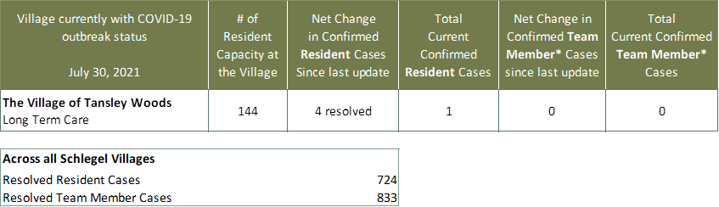

*Team member reporting may include “essential caregivers,” agency staff, contracted service providers (such as fire inspectors or general maintenance service people), as well as care providers contracted by Local Health Integration Units.