Friday, July 3 – 2:00 p.m.
Organizational Update

Good afternoon,

We’re quite happy to report that The Village of Erin Meadows long-term care neighbourhoods are no longer in enhanced outbreak surveillance as of yesterday and the Village is looking forward to welcoming loved ones back for outdoor visits. We thank everyone for their patience as the team prepares for this transition and ask that loved ones who are booking their visits respect the need for extra precautions. The teams in all Villages have worked exceptionally hard and nobody wants to be back in an outbreak situation.

As for our other affected Villages, there are no other changes to report. We continue to receive results of ongoing testing and have seen nothing but negative results. We look forward to the continuation of this trend and we hope to see our other affected Villages out of outbreak soon.

Thanks to everyone for their hard work and ongoing support.

Please note: Chart formatting
*The number in the first column of the chart represents the full capacity of each Village in terms of resident numbers.
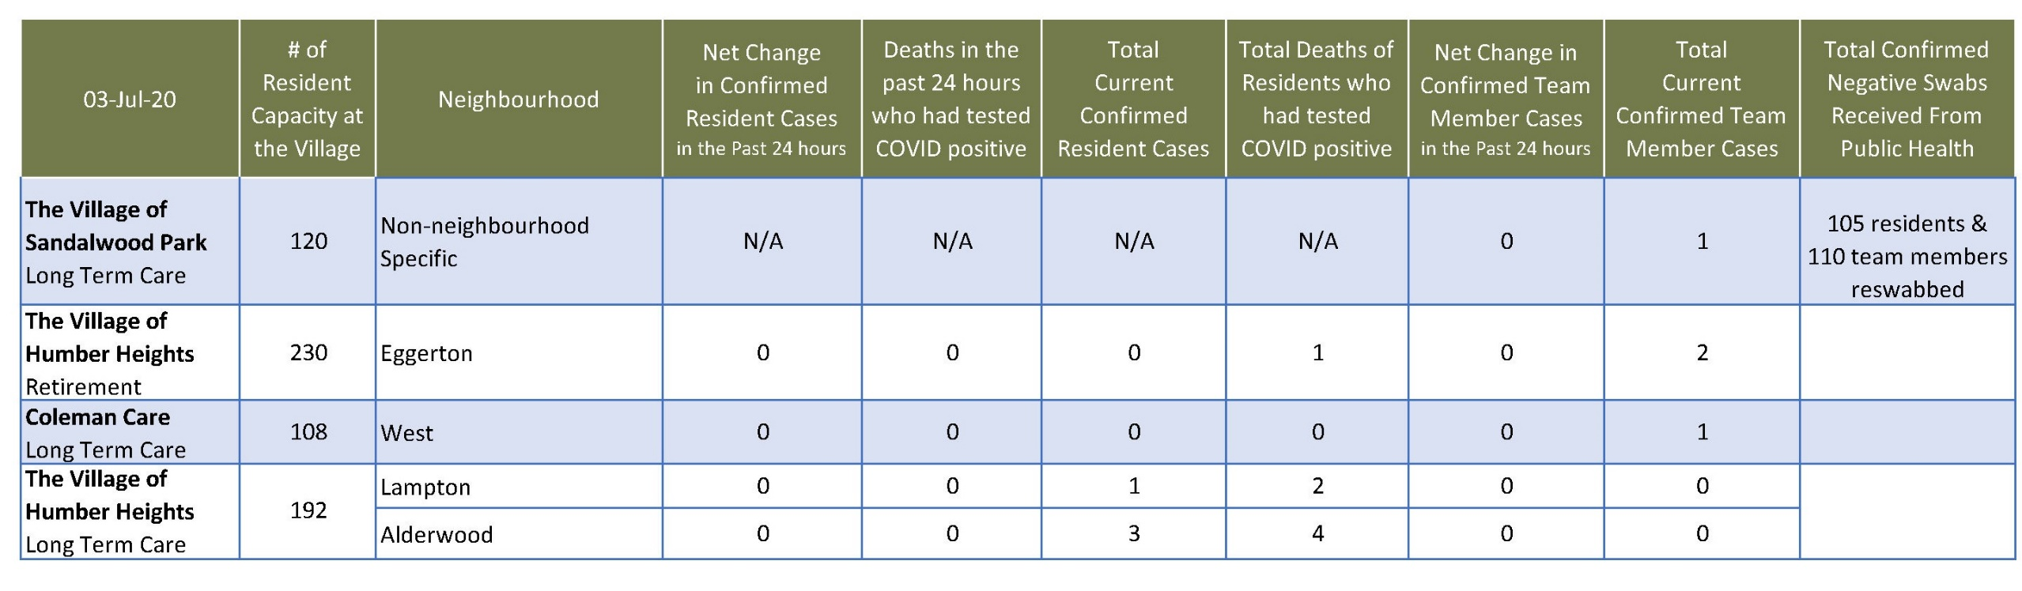
Total Resolved Cases Across Schlegel Villages as of Today:
Residents: 181
Team members: 131

