Saturday, July 4 – 12:00 p.m.
Organizational Update

Good afternoon,

Aside from continual negative test results, which we are extremely happy to see, we have nothing new to report. The fact that we have seen no new positive cases in any Village is reason for optimism, considering every team member was tested twice in the month of June. We are hopeful that in the coming days, we will receive confirmation that our last three affected Villages will be considered COVID-19 free.

This hope and optimism, however, must be tempered with fact: we know the strain this virus can present among older adults and people who have underlying health conditions, and we thank everyone for their continued respect for our precautions and protocols.

Please note: Chart formatting
*The number in the first column of the chart represents the full capacity of each Village in terms of resident numbers.
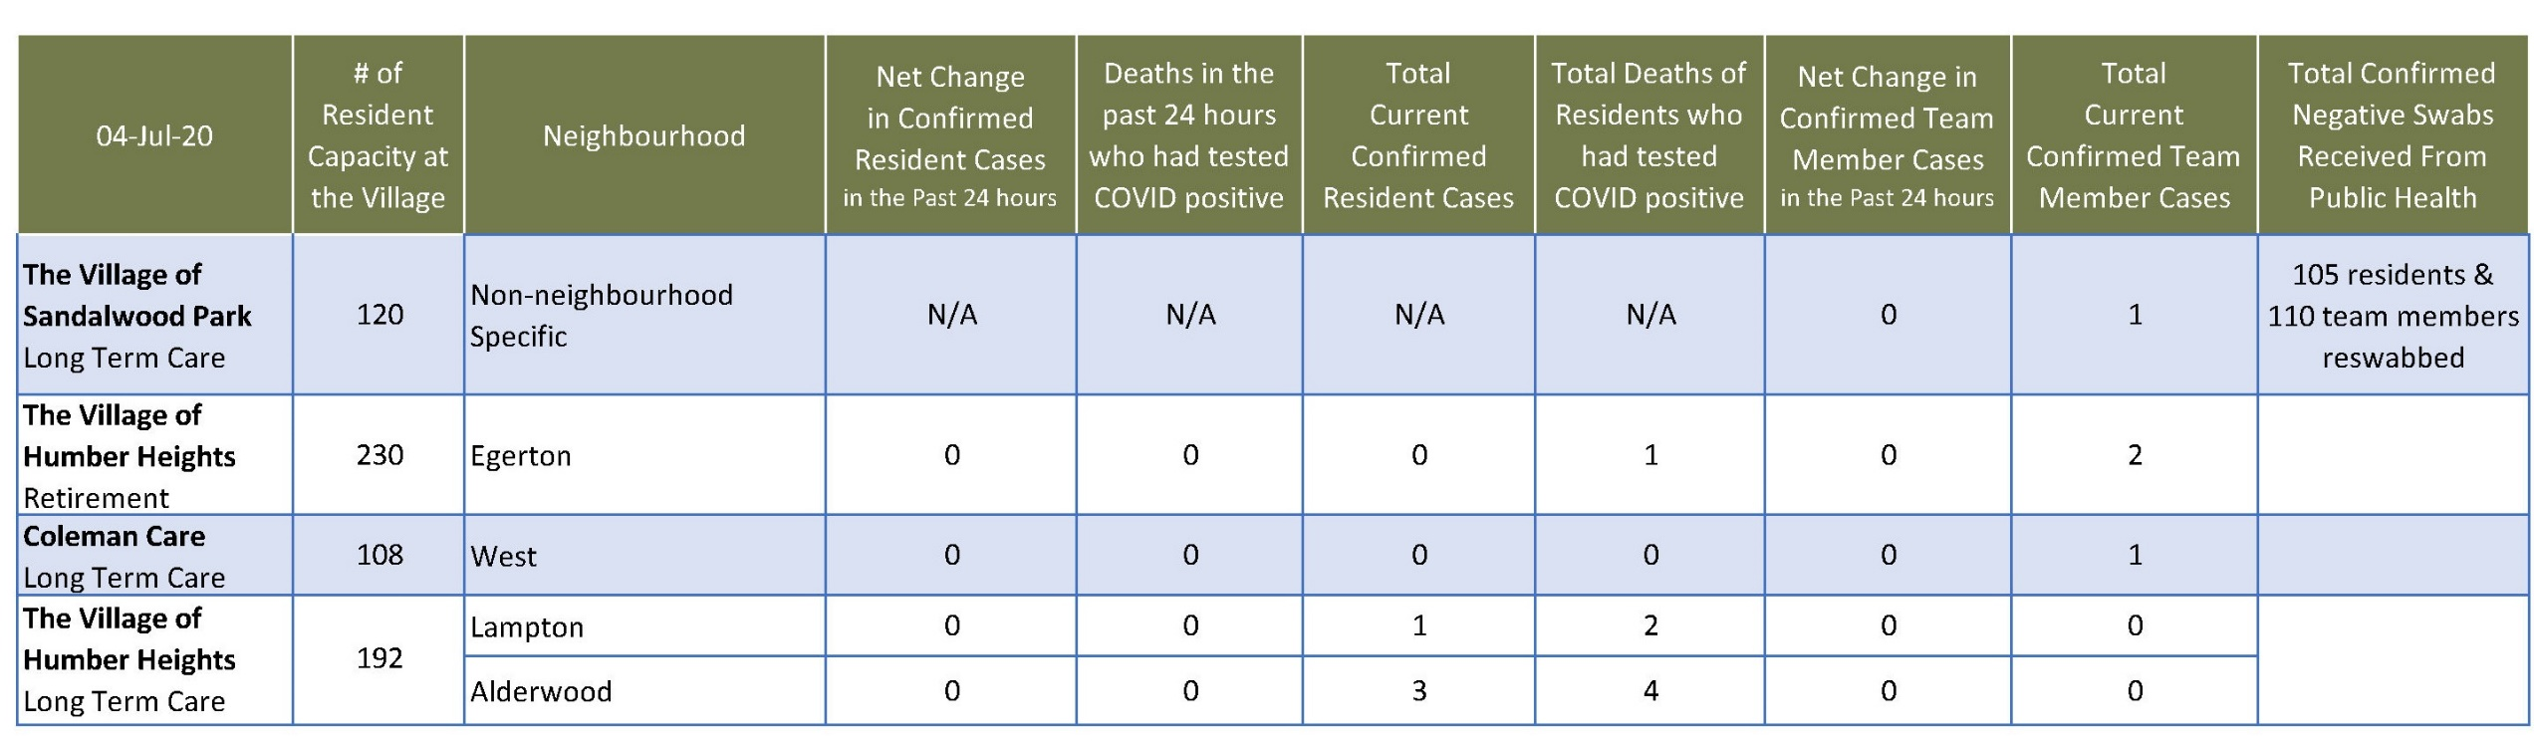
Total Resolved Cases Across Schlegel Villages as of Today:
Residents: 181
Team members: 131

