Sunday, July 5 – 12:00 p.m.
Organizational Update

Good Afternoon,

Once again, we have no changes to report in any of our remaining Villages affected by COVID-19, and no new Villages on our watch list. We find hope in the stability we’ve seen in recent days, reinforcing the importance of the protocols we have in place in terms of visitation and short leaves of absence for retirement residents.

As sincerely appreciate everyone’s respect for these protocols and we look forward to resolving the remaining few cases in our affected Villages. We wish everyone a beautiful Sunday and offer our gratitude for the continued support everyone in our villages feels from neighbours, friends and loved ones.

Thank you.

Please note: Chart formatting
*The number in the first column of the chart represents the full capacity of each Village in terms of resident numbers.
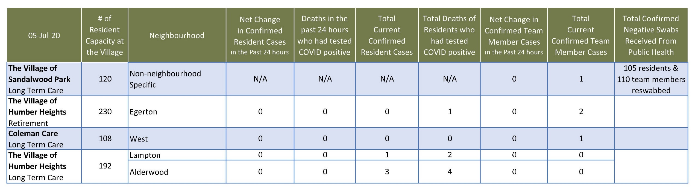
Total Resolved Cases Across Schlegel Villages as of Today:
Residents: 181
Team members: 131

