Monday, July 6 – 1:30 p.m.
Organizational Update

Good Afternoon,

We want to again offer thanks to team members in all of our Villages who continue to go through regular testing to help public health track any possibility of the virus. We have seen many negative results, but today we must report that a team member who was last in The Village of Humber Heights nearly two weeks ago has since tested positive. This case is added to our chart and the Village will work closely with Public Health through continued outbreak surveillance. We wish this team member a quick and safe resolution.

We are thankful to say there are no other changes to report in our affected Villages and no new Villages added, making us grateful that this this has been the trend of late. Our goal since the start of the pandemic has been to be as open and transparent as possible and, with that in mind, we feel based on current trends that we can reduce the frequency of communications from daily to every Monday, Wednesday and Friday, and Saturdays as needed. Our teams will continue following all developments from either the provincial, local public health or Village levels and should any need arise, the communication will become more frequent as necessary.

In the meantime, we hope to share more stories of strength and success from within our Villages as the communication team focuses more on these. We invite people to watch The Village Voice page here for updated stories.

Thank you.

Please note: Chart formatting
*The number in the first column of the chart represents the full capacity of each Village in terms of resident numbers.
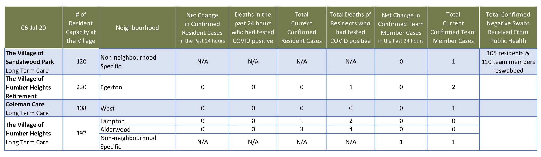
Total Resolved Cases Across Schlegel Villages as of Today:
Residents: 181
Team members: 131

