Wednesday, July 8 – 2:00 p.m.
Organizational Update

Good afternoon,
Since our last report on Monday, we have seen some extremely heartening developments. On Monday, Public Health officials declared the Village of Sandalwood Park free from COVID-19 and today we learned that Coleman Care Centre is now officially out of outbreak monitoring. There has been no change in status at Humber Heights retirement but we’re happy to say that two more residents in the long-term care neighbourhoods have been ‘resolved.’

Our teams and residents in these last remaining affected Villages are to be commended for their efforts to manage any potential spread of the virus and we look forward to seeing the final cases at Humber Heights resolved soon. All of our teams in every Village continue to inspire us in their efforts: their use of PPE in the heat of the summer; the ongoing testing, which is not the most pleasant of experiences; their willingness to do all they can to connect residents and loved ones; all the extra time they give to residents and their dedication to each other. We thank each and every one of these great people for all they do every day, and we thank the wider community for the ongoing support.

We remind all who continue to visit our information page that as things have slowed, we have moved from daily updates to every Monday, Wednesday, Friday and possibly Saturdays when warranted. Our goal since the start of the pandemic has been to be as open and transparent as possible and, should any need arise, the communication will become more frequent as necessary.

Thank you.

Please note: Chart formatting
*The number in the first column of the chart represents the full capacity of each Village in terms of resident numbers.
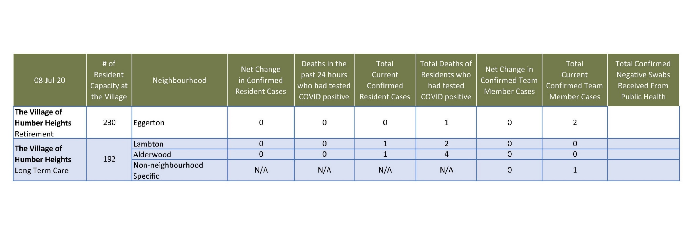
Total Resolved Cases Across Schlegel Villages as of Today:
Residents: 183
Team members: 133

