Thursday, May 21 – 2:00 p.m.
Organizational Update

Good afternoon,

We are happy to report the overall trend in our affected villages continues to offer hope that positive progress is being made in our efforts against COVID-19. There were no changes in any of our affected Villages, though we are awaiting the results of testing in a few different Villages, which will hopefully result in more resolved cases and the removal of some Villages from active outbreak status.

Our non-affected Villages continue to work hard to keep the virus at bay, and we once again thank everyone for their continued dedication.

We also want to remind families and loved ones that despite the fact that in the wider public sphere, the lockdown as we’ve known it for the past months is opening up, long-term care and retirement settings must continue all precautionary measures and restrictions to protect our residents. The moment we know more about a possible safe easement of these restrictions, we will share that information. For now, please know that each Village is working hard to find safe ways to get out and enjoy some of the beautiful weather that is now upon us.

We thank everyone for their continued patience and understanding.

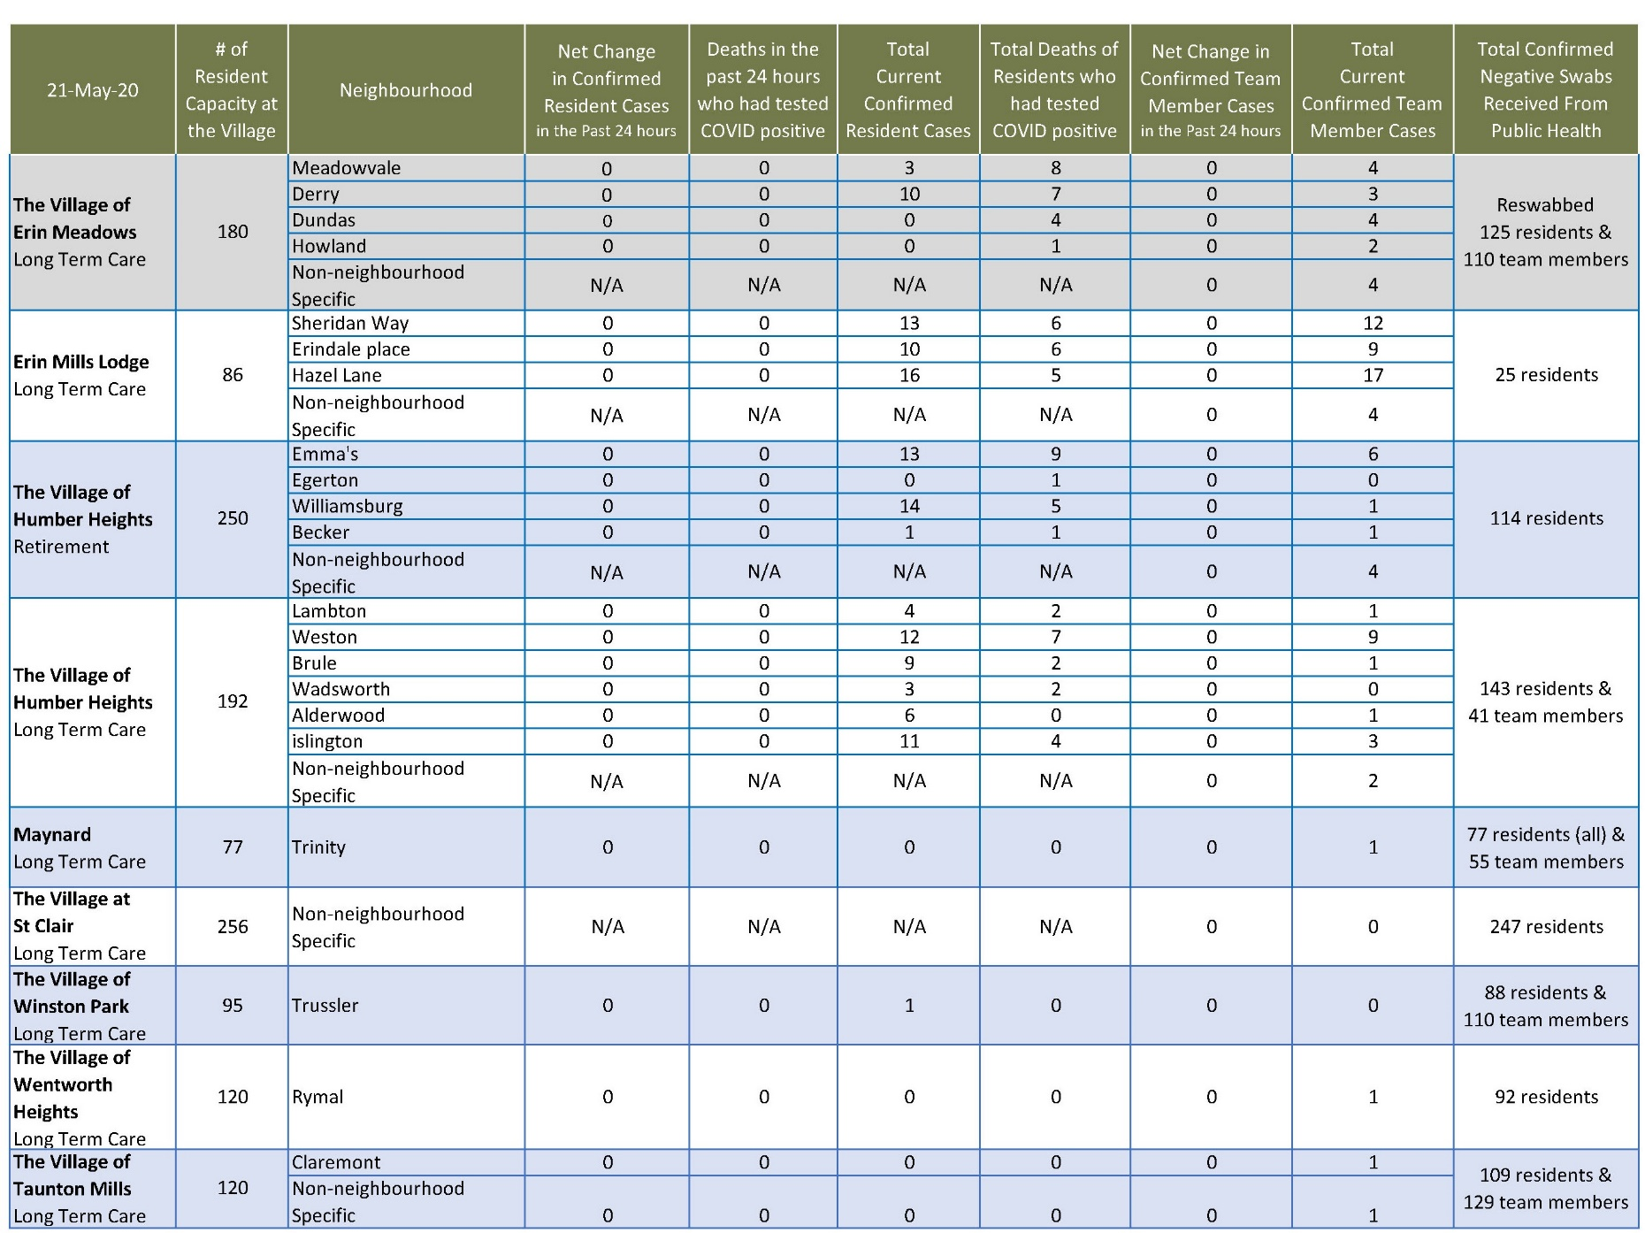
Please note: Chart formatting
*The number in the first column of the chart represents the full capacity of each Village in terms of resident numbers.

Total Resolved Cases Across Schlegel Villages as of Today:
Residents: 56
Team members: 34

