Friday, May 22 – 1:30 p.m.
Organizational Update

Good afternoon,
With great pleasure we can announce that yesterday afternoon, public health officials in Hamilton and Windsor declared that The Village of Wentworth Heights and The Village at St. Clair are both free of COVID-19 and are off the outbreak list.

Both Villages only had one positive case reported and, thankfully, they were both resolved without serious illness; the teams worked exceptionally hard to add all precautions and keep the virus from spreading beyond one person, and our deepest gratitude flows to them as they celebrate today.

Beyond that good news, we are also grateful to say that there were several more ‘resolved’ cases in both retirement and long-term care at The Village of Humber Heights, and we are hopeful that the positive trend we have seen over the past week will continue.

Our teams in all Villages continue to work tirelessly to support our residents during these difficult times, and they inspire us with their compassion and commitment.

Yes, there are many signs of hope, but at this time, unfortunately, we must still keep our restrictions in place in all Villages to protect our residents. The moment we know more about a possible safe easement of these restrictions, we will share this news with loved ones and residents, and we thank everyone for their continued patience and understanding.

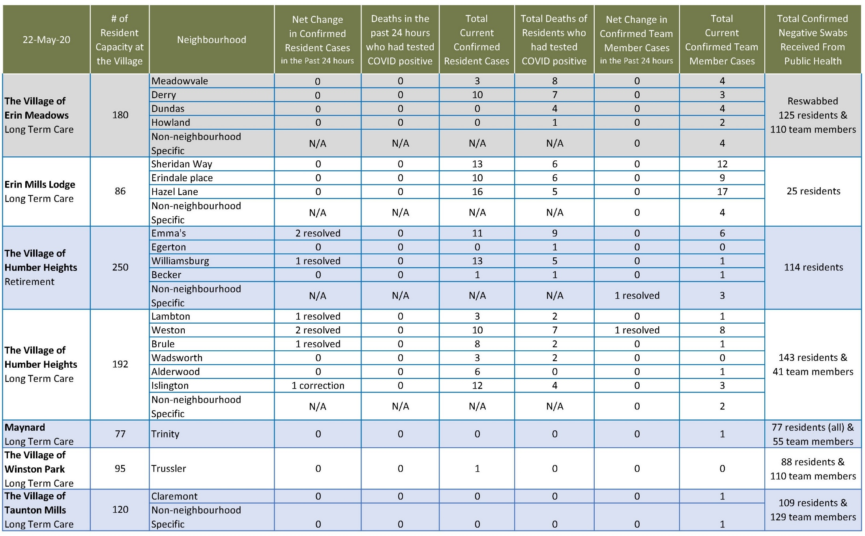
Please note: Chart formatting
*The number in the first column of the chart represents the full capacity of each Village in terms of resident numbers.

Total Resolved Cases Across Schlegel Villages as of Today:
Residents: 63
Team members: 36

