Saturday, May 23 – 12:30 p.m.
Organizational Update

Good afternoon,
With great sorrow we share news today that a resident from the Islington neighbourhood in The Village of Humber Heights who had tested positive for COVID-19 passed away yesterday. We have seen several signs of hope over the past days – ‘resolved’ cases and two Villages removed from outbreak status yesterday – but with this news today we are again reminded of the danger COVID-19 presents for older adults and people who have underlying health conditions.
Our condolences are with the team at Humber Heights and with the family and loved ones who are in the midst of acute grief today. Our teams in all Villages continue to pour their complete dedication into the support of our residents, and the news today reinforces why this is of utmost importance.
We see the fruits of this labour in the many ‘resolved’ cases we can announce today – most notably at Erin Mills Lodge, where more than 20 residents were declared free from COVID-19 yesterday. The Village of Erin Meadows also saw some ‘resolved’ cases yesterday and we look forward to more of these results as Public Health continues to process the ongoing testing underway in our communities.
We again thank our neighbours, loved ones and friends for their patience and understanding as we continue to work so hard to support our residents. All of our precautionary measures and restrictions on all but the most essential of visitors will remain in place for the time being until we are certain it is safe to begin welcoming people back to our Villages.

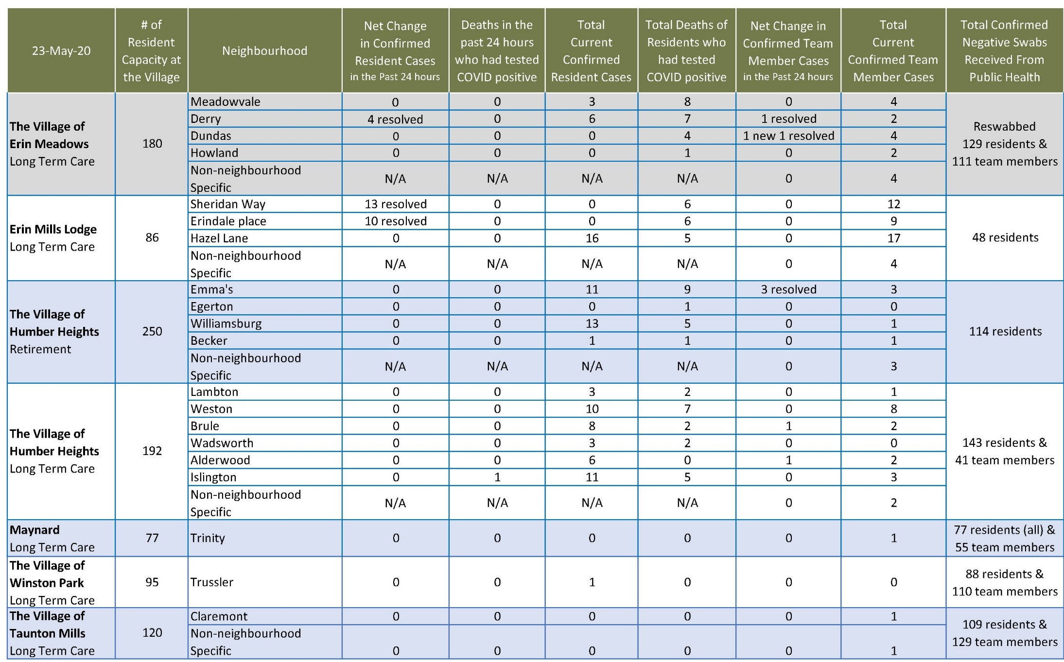
Please note: Chart formatting
*The number in the first column of the chart represents the full capacity of each Village in terms of resident numbers.

Total Resolved Cases Across Schlegel Villages as of Today:
Residents: 90
Team members: 41

