Sunday, May 24 – 11:30 a.m.
Organizational Update

Good afternoon,

We are very pleased to announce that one resident who had tested positive at The Village of Winston Park has been declared ‘resolved,’ and this morning Public Health officially removed The Village from the outbreak list. Beyond that great news we’re happy to report another day with no new cases of COVID-19 added in any of our Villages and we are hopeful that once final testing results come back at Maynard Nursing Home, they will be removed from outbreak status as well.

All of our teams continue to work exceptionally hard to support our residents during these difficult days, and we are hopeful that more information will come soon regarding the lessening of some of the restrictions we have in place. The safety and well being of residents and team members, however, is our most important priority, so for now all of our visitor restrictions and precautionary measures must remain fully in place.

We thank everyone for their continued patience and understanding.

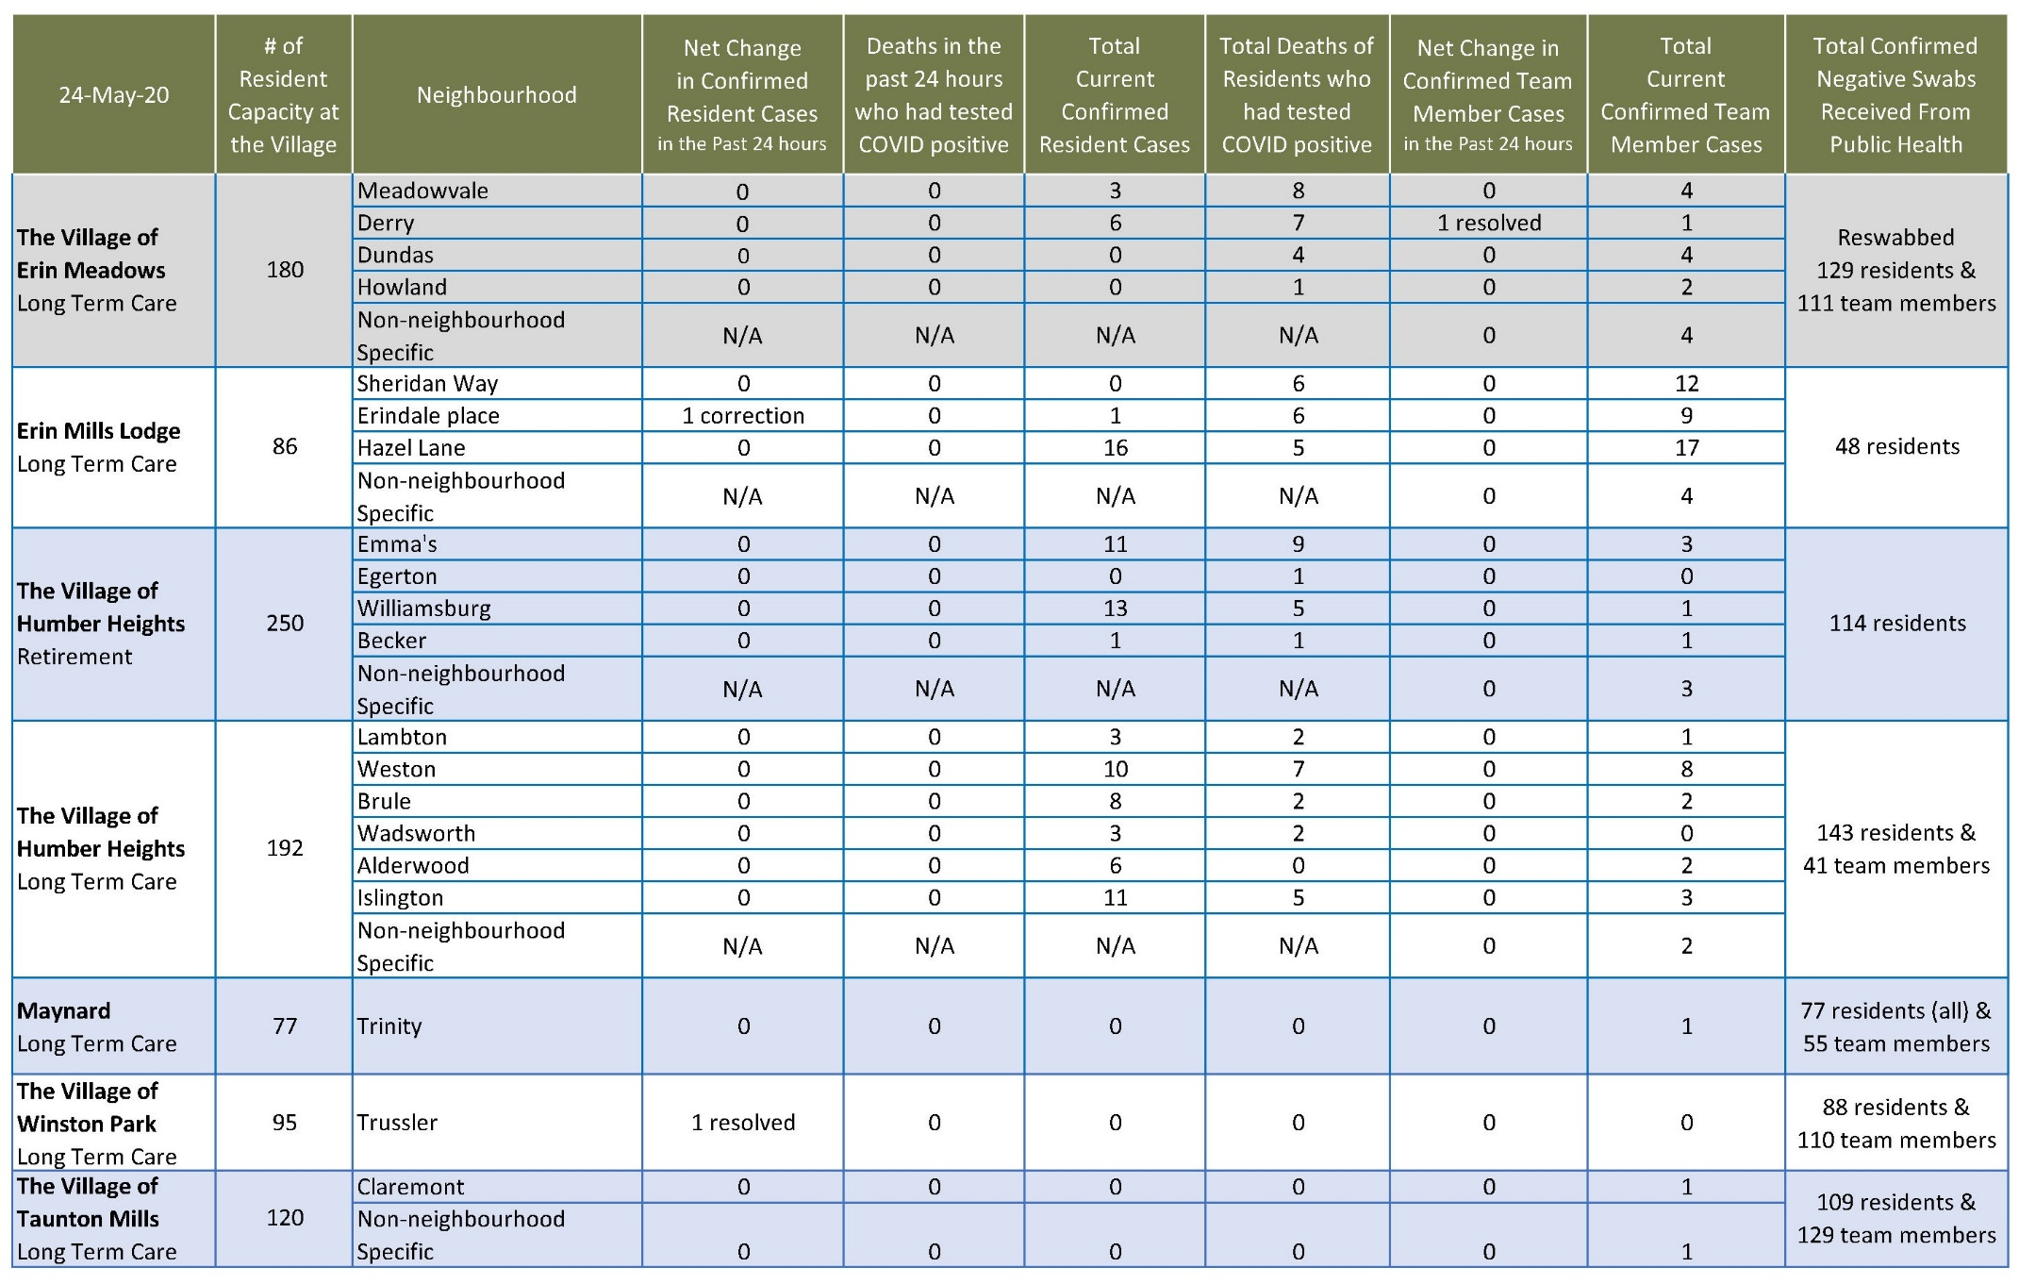
Please note: Chart formatting
*The number in the first column of the chart represents the full capacity of each Village in terms of resident numbers.
*The chart will be updated tomorrow to reflect the removal of Winston Park.

Total Resolved Cases Across Schlegel Villages as of Today:
Residents: 90
Team members: 43

