Monday, May 25 – 2:00 p.m.
Organizational Update

Good afternoon,

We are again pleased to offer an overall positive update today. Ongoing testing did add two more resident cases; one at Erin Meadows long-term care and one at Erin Mills Lodge, but we are grateful to say that 13 residents at Erin Mills Lodge were also classed as ‘resolved.’ At The Village of Taunton Mills, Maynard Nursing Home and both the retirement and long-term care neighbourhoods at Humber Heights there were no new cases added, and we are hopeful that more ‘resolved’ cases will be added as test results come back in all Villages.

As we look to signs of hope and we thank our teams for their energy in supporting residents safely with all of our precautionary measures, we are reminded of some reasons for heightened vigilance. The province is reporting larger numbers of new cases of late and we’ve seen examples of how challenging it is for people to maintain safe physical distancing in the community – most notably in Toronto parks over the weekend. The numbers in our Villages are offering signs of the progress we want to see, but we must continue with all precautionary measure to ensure the spike in community numbers is not mirrored in our Villages where we know residents are most vulnerable to the detrimental effects of the virus.

We continue to thank loved ones and family members for respecting the need to keep these measures in place

Thank you.

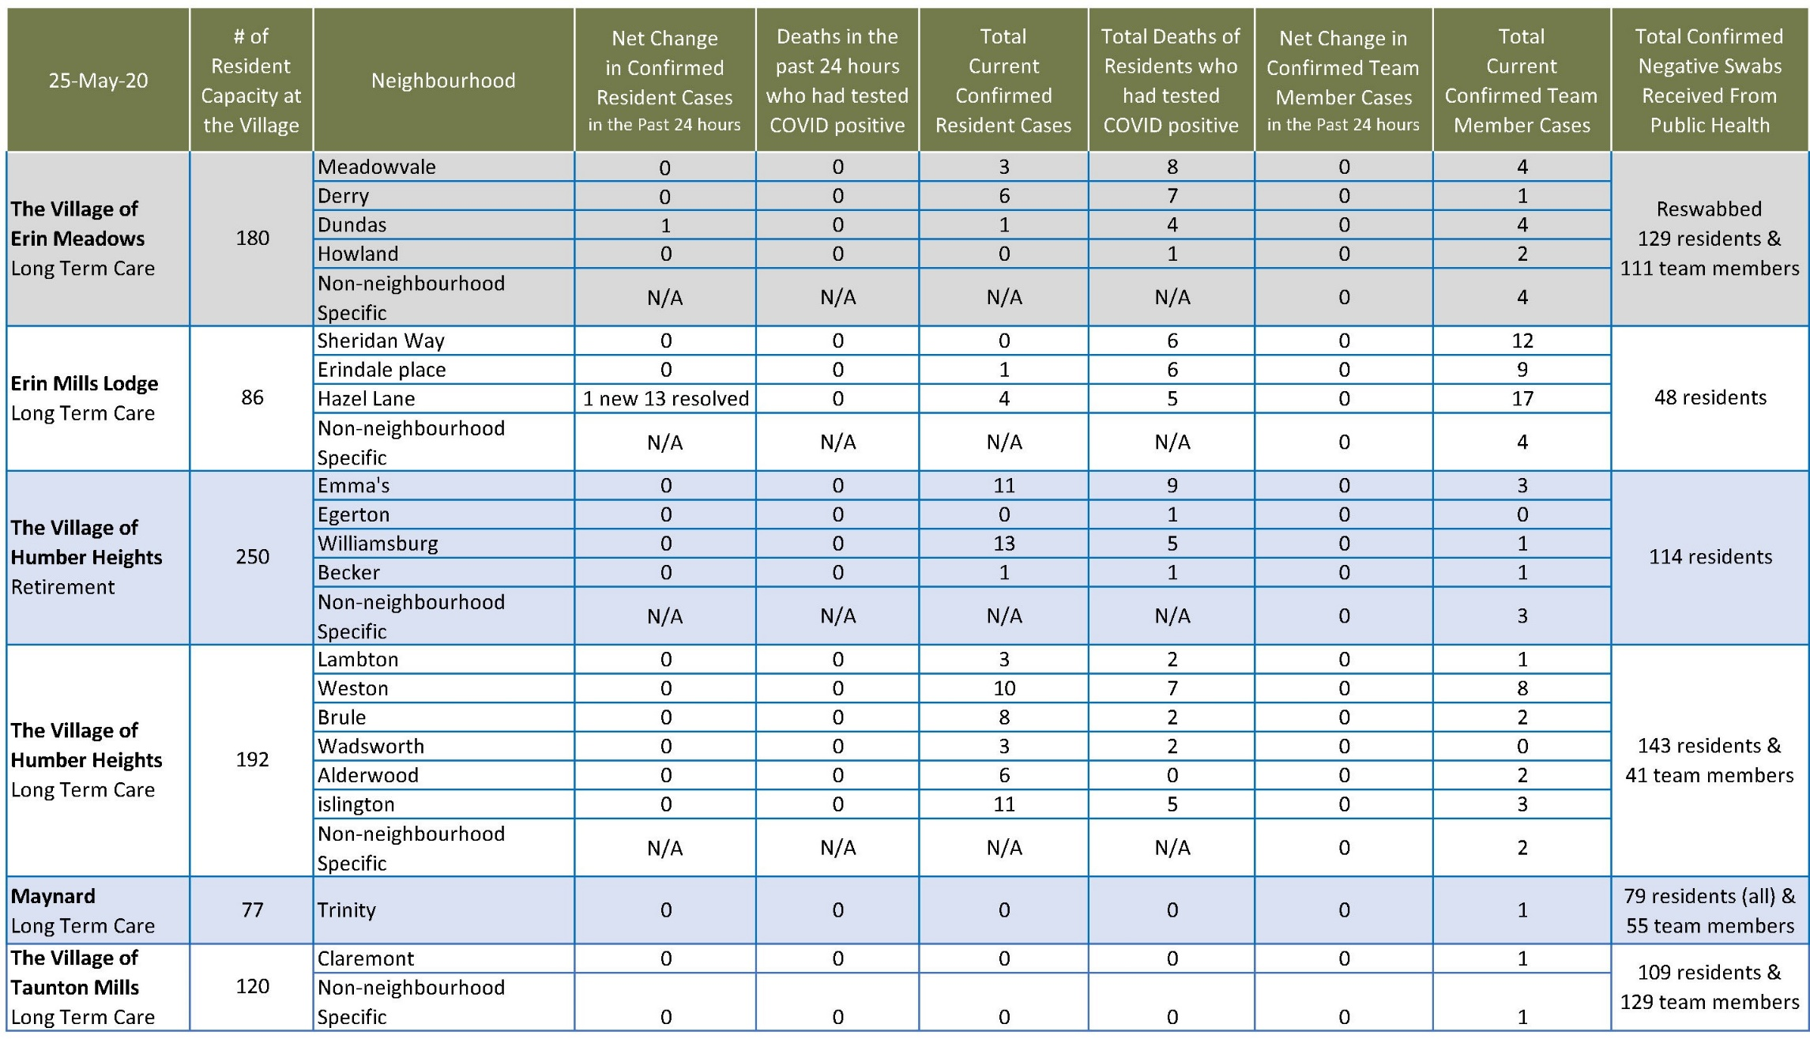
Please note: Chart formatting
*The number in the first column of the chart represents the full capacity of each Village in terms of resident numbers.

Total Resolved Cases Across Schlegel Villages as of Today:
Residents: 104
Team members: 42
*Please note: we made an error in yesterday’s tabulation; it should have been 91 residents and 42 team members, not 90 and 43.

