Tuesday, May 26 – 2:00 p.m.
Organizational Update

Good afternoon,
We’re pleased to say that we continue to see more ‘resolved’ cases as more testing results come back in some of our Villages most affected by COVID-19. Yesterday, Erin Mills Lodge resolved eight team members and at Humber Heights Retirement, eight residents in Williamsburg, one resident and a team member in Emma’s and a non-neighbourhood specific team member were all classed as resolved.
We did see two additional positive cases, unfortunately: a team member at Humber Heights long-term care and a team member at Erin Meadows; our best wishes go out to all affected for a quick and safe resolution.
There are no other Villages added to our list and no other changes to report, so we continue to offer our gratitude to our teams and to our residents and loved ones for their continued support, patience and understanding.
Thank you.

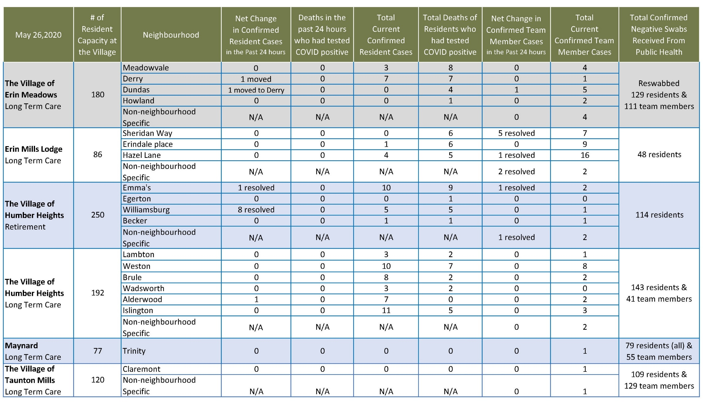
Please note: Chart formatting
*The number in the first column of the chart represents the full capacity of each Village in terms of resident numbers.

Total Resolved Cases Across Schlegel Villages as of Today:
Residents: 113
Team members: 52

