Wednesday, May 27 – 4:00 p.m.
Organizational Update

Good afternoon,
After several days reporting positive progress in our Villages affected by COVID-19, we are reminded today of the toll the virus can take upon older adults and those with underlying health conditions. We are deeply saddened to report that two residents from the Alderwood neighbourhood of Humber Heights long-term care who had tested positive for COVID-19 passed away, and our deepest condolences are with their loved ones today and the team members who were close with them.
We find solace in the fact that Erin Mills Lodge reported 26 ‘resolved’ team members yesterday and also in the fact that we saw no new additional cases and we are hopeful that Public Health officials will soon remove Maynard Nursing Home and The Village of Taunton Mills from active outbreak status.
Lastly, we wanted to mention a report that the Canadian Forces released yesterday related to their experience in 5 of Ontario’s 630 LTC homes. This small group of homes was limited to these five following an initial assessment by government officials suggesting they were at greatest risk and most in need of aid. We must first offer our gratitude to the Canadian Forces teams deployed to these five homes in desperate times; these women and men stepped into a difficult and risky environment that was certainly exacerbated, if not created, by the pandemic. Just like the thousands of front-line care partners supporting Ontario’s 77,000 LTC residents, these professionals did so with compassion and dedication.
The report highlights numerous concerns and provides a unique perspective through the lens of those soldiers struggling as they battle against COVID-19 in the five homes. We share a deep concern for the homes and providers that are struggling to provide the most basic of care, but we also want to acknowledge the vast majority of homes and care providers who continue to offer exceptional support for LTC residents during extremely difficult times.
In our Villages, we have conducted internal and external Infection Prevention and Control (IPAC) Assessments in collaboration with Local Health Integration Network and hospital teams, and we are proud of the results we’ve seen in all Villages. In terms of staffing, which the report points to as a major contributing factor amongst the problematic circumstances in those five homes, Schlegel Villages has a central team entirely focused on the recruitment and retention of our quality team members. They have been doing an exceptional job stabilizing our workforce. We’re also grateful to point to the confidence we maintain in our central supply of PPE and we know we can provide our teams with all they need; that and ongoing education around proper PPE use helps us do all we can to protect both our team members and residents.
We are as proud of the professionalism of the vast majority of quality front-line care partners across the province who are working through this crisis as we are of the teams in all of our Villages. In light of the challenges we’ve seen in recent months, we look forward to working with our partners and policy makers to create a better future for the sector.

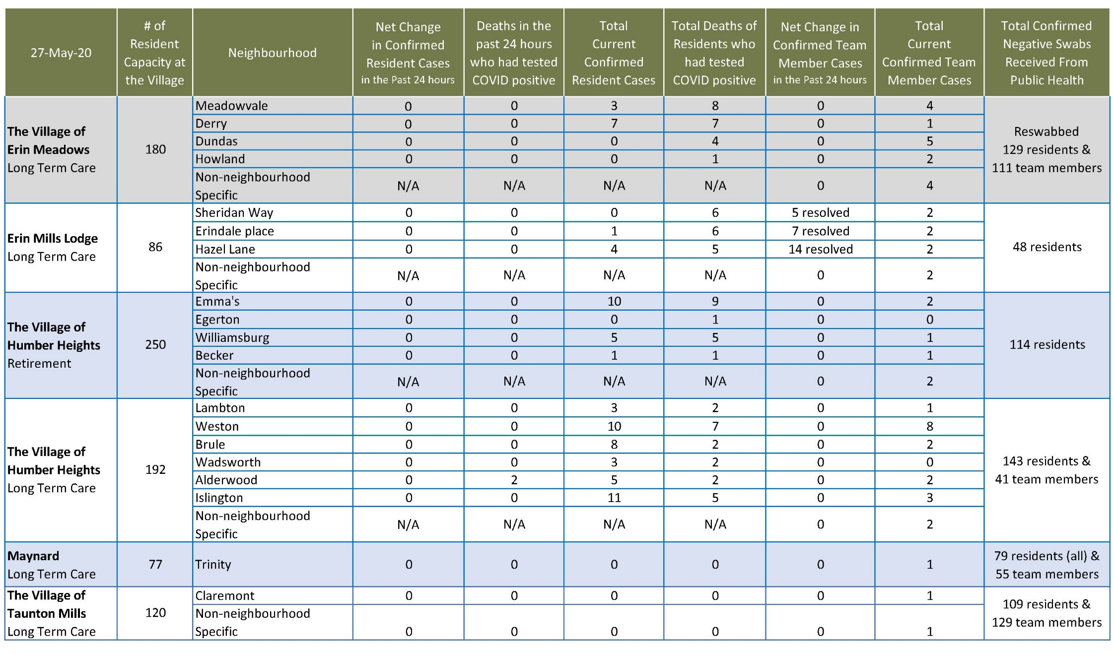
Please note: Chart formatting
*The number in the first column of the chart represents the full capacity of each Village in terms of resident numbers.

Total Resolved Cases Across Schlegel Villages as of Today:
Residents: 113
Team members: 78

