Wednesday, May 5 – 4:30 p.m.
Organizational Update

Good afternoon,
We’re happy to share news that the one team member case connected to The Village at University Gates was resolved, leaving one lone case in The Village.
We have had to add The Village of Glendale Crossing to our chart as Public Health officials there have decided to declare outbreak status in three neighbourhoods based on four positive team member cases. It has been 10 days since three of these team members were last in the Village and we are grateful that all resident tests have come back negative. In terms of the provincial mandate around outbreak status, the definition of Confirmed Outbreak, according to Public Health guidance, is: two or more lab-confirmed cases in residents/staff/visitors in a long-term care home, with an epidemiological link, within a 14-day period, where at least one case likely acquired the infection in the home.
The definition of a suspect outbreak refers to a single, lab-confirmed COVID-19 case in a resident. As always, local public health units have the discretion to declare an outbreak and end an outbreak. In all of our Villages, our teams continue to monitor everyone closely and regular, rapid testing is underway to ensure that any possible case is identified quickly and appropriate Infection Prevention and Control measures can be put in place.
The team at Glendale Crossing will continue to work alongside public health to resolve this as soon as possible.
Late yesterday, a series of updated guidance documents to support changes in Directive #3 were released by the Chief Medical Officer of Health. We are eager to safely follow this guidance but, in many respects, they will only come into action once the provincial stay-at-home order is lifted and regions are again in status levels based on the regional colour coding. In all respects, we will continue to follow Public Health guidance.

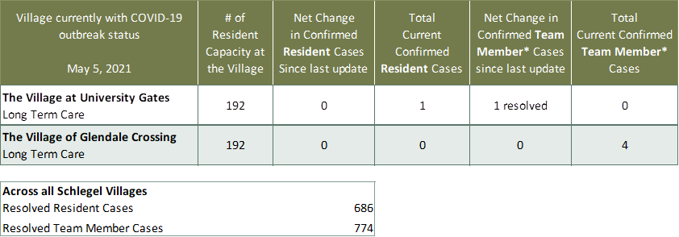
Villages with Outbreak Status
*Team member reporting may include “essential caregivers,” agency staff, contracted service providers (such as fire inspectors or general maintenance service people), as well as care providers contracted by Local Health Integration Units.

