Monday, November 16 – 2:00 p.m.
Organizational Update

Good afternoon,
Today we offer our deepest condolences to the families of three residents from Hamilton Continuing Care who had tested positive for COVID-19 and passed away over the weekend. The small team at the home, which truly is a family, feels these losses with immense sorrow and we stand with them all in support. As three other cases there resolved over the weekend, there are now 15 active resident cases, and we are hoping for more resolved cases as early as this evening.
At The Village of Wentworth Heights, four resident cases have resolved leaving five active cases; one new team member from the Becker neighbourhood was also identified as positive for COVID-19.
The Village of Tansley Woods Retirement Home still has one neighbourhood considered to be in outbreak, but the rest of the Village is slowly opening up and we are grateful for this news. The long-term care home there is not in outbreak, though the team is monitoring everyone closely, as is the case in all Villages, regardless of outbreak status.
There are no changes to report at The Village of Winston Park Retirement Home, nor retirement at The Village of Riverside Glen. Riverside Glen Long-Term Care resolved another team member, leaving only the Mapleton neighbourhood under observation.
There are no changes at Pinehaven Nursing Home, nor The Village of Arbour Trails.
Lastly, The Village of Sandalwood Park in Brampton is also under observation as there were two team member cases return positive. So far, 115 resident tests have come back negative and more than 50 team member tests; The Village is not considered to be in outbreak at this time.
As we continue to point out, many of our Villages are in areas where there is a high rate of community transmission and as our sad news from Hamilton Continuing Care reminds us, this virus can have a devastating impact on older adults and those with underlying health conditions. Warnings have been sounding for months about the danger of the second wave, and our teams in every Village are doing all they can to safely support residents and each other. It takes a Village to care, however, so thank you to families and caregivers for the ongoing support and cooperation.
Thank you.

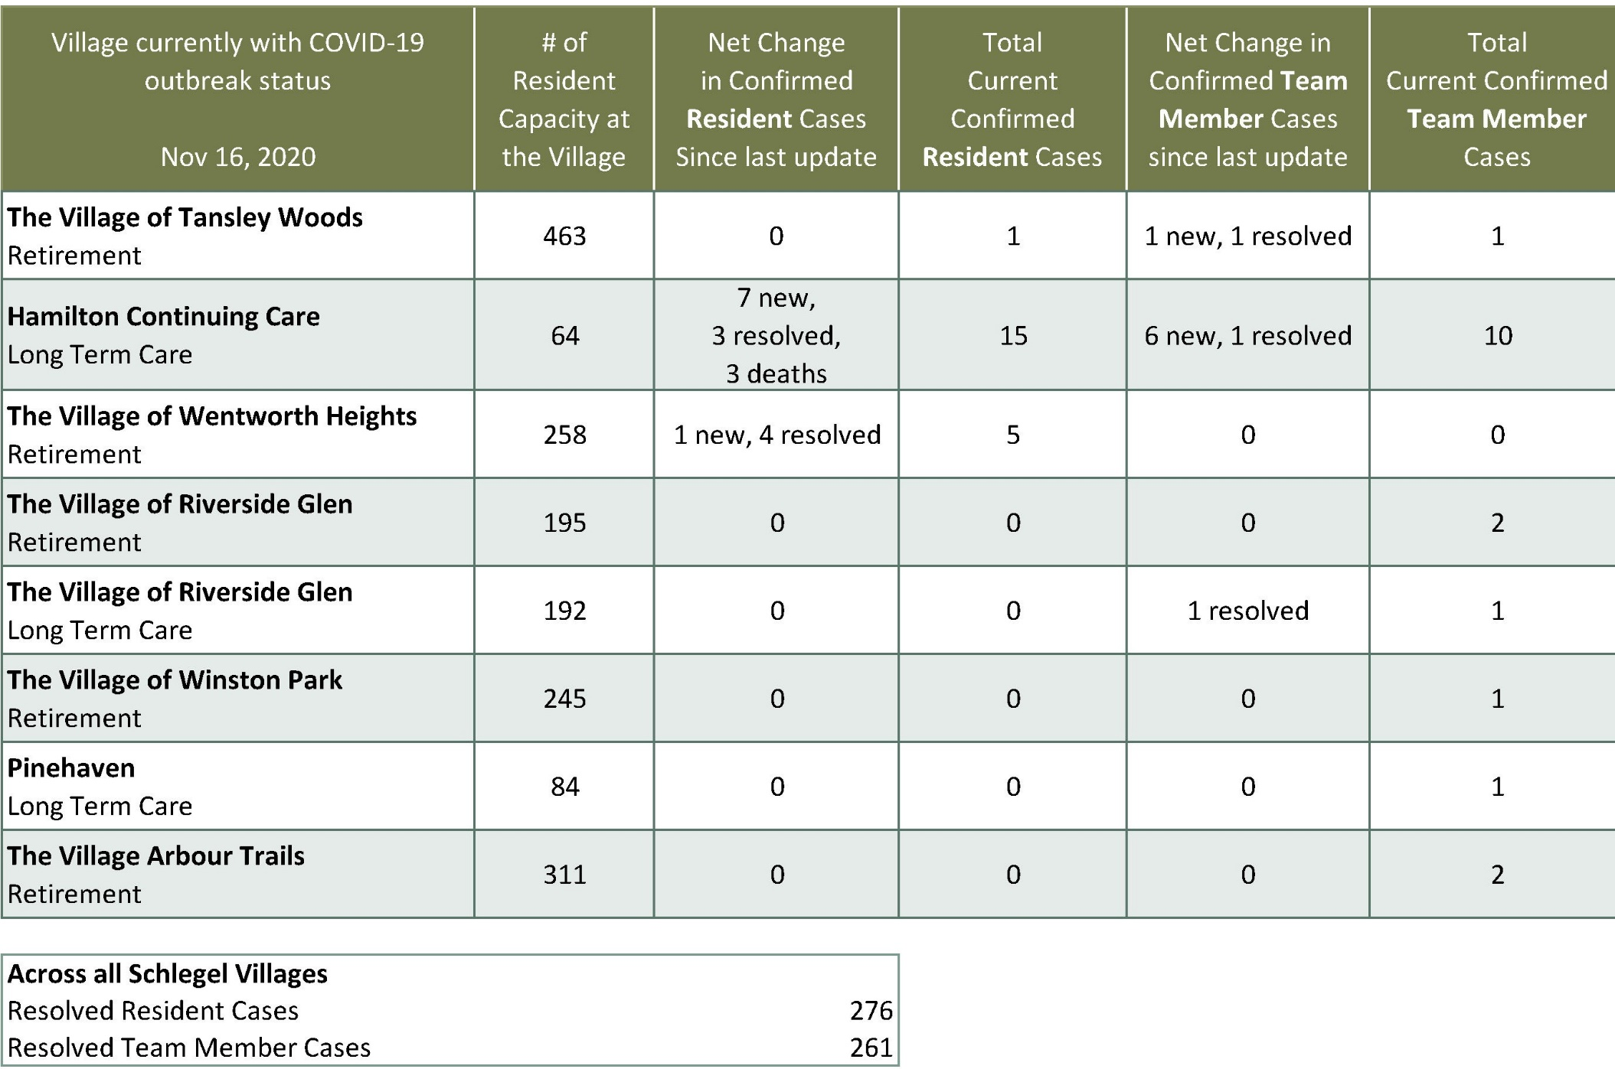
Please note: Chart formatting
*The number in the first column of the chart represents the full capacity of each Village in terms of resident numbers.

