Wednesday, November 18 – 2:00 p.m.
Organizational Update

Good afternoon,
Since our last update Monday, the small family at Hamilton Continuing Care has lost another resident who had tested positive for COVID-19. As we have said many times before, to lose any resident from any Village for any reason is difficult for our teams, and we offer our deep condolences to everyone who feels this loss today. There are two additional positive resident cases but also five resolved residents. We sincerely offer our best wishes to everyone for a safe and speedy resolution.
At The Village of Tansley Woods Retirement Home, the last remaining resident case was resolved and we are awaiting the final team member resolution to officially declare the outbreak over.
At The Village of Wentworth Heights Retirement Home, one more resident has been resolved since our last update, leaving four active resident cases and we are hopeful we will soon see more resolved. There is one active team member case there as well.
The Village of Riverside Glen Retirement Home also saw one team member resolved, leaving only one team member case there. We are also hoping the only case in the Mapleton neighbourhood at Riverside Glen Long-Term care will be resolved in the coming days.
There are no other changes to report in any of our other affected Villages, but we do have to add Erin Mills Lodge in Mississauga to our chart, because on Monday evening a positive team member case was confirmed. All cohorting measures and precautions are in place and we know the team there has all they need, both internally and with the support of the entire organization, to manage.
Thank you

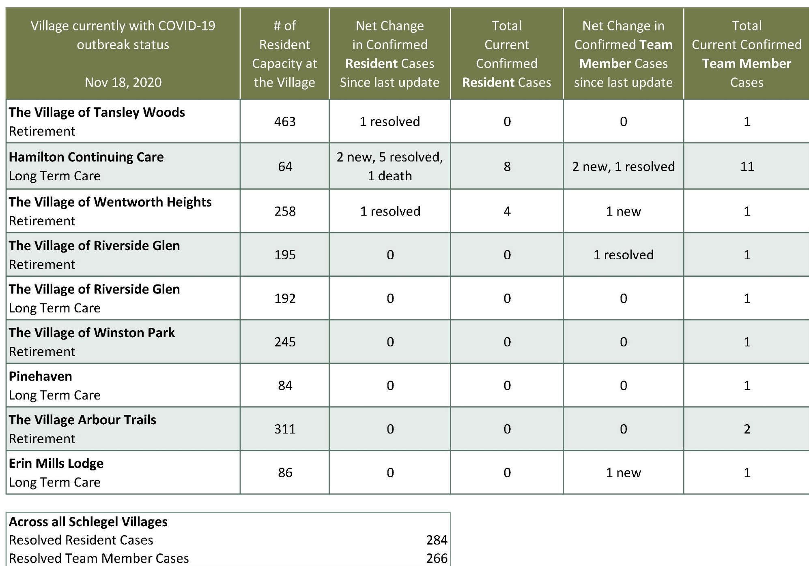
Please note: Chart formatting
*The number in the first column of the chart represents the full capacity of each Village in terms of resident numbers.

