Friday, November 13 – 3:00 p.m.
Organizational Update

Good afternoon,
Since our last update Wednesday, we learned that The Village of Arbour Trails in Guelph had two different agency team members, each of whom work one-on-one with the same resident in Emma’s neighbourhood, have tested positive. The resident test came back negative, but as a precaution The Village is considered in outbreak until the 19th and the resident will be in quarantine.
Also, Pinehaven Nursing Home, with one active team member case, was also placed in outbreak status by Public Health Officials.
The Retirement Neighbourhoods at The Village of Tansley Woods received 47 Team Member test results back and one of them was shown to be positive. However, they are retesting that person to be sure of the result, as there are no suspected contacts at all and no symptoms. The long-term care neighbourhoods at Tansley Woods are also in heightened surveillance at this time, with two possible team member cases there and the team is in direct contact with Public Health officials to monitor the situation.
At Hamilton Continuing Care, there currently 14 active resident cases and one new team member case bringing the total number of affected team member to five.
The Village of Wentworth Heights Retirement Home has eight active resident cases, though some media reports have mistakenly suggested the Long-term Care Home at Wentworth Heights is in outbreak. We are working to correct that mistake. Also, media has reported that a resident at Wentworth Heights retirement who passed away on Nov. 10 was COVID-19 related. However, the Village team had been assured it was not, as the resident had tested negative prior to passing. Regardless, the entire team there was saddened by the loss as each resident is a valued member of the Village community and it is never easy to say goodbye. Our thoughts and condolences are with loved ones.
There are no other changes to report in any of our other Villages and we continue to offer gratitude for the support and encouragement our teams and residents receive every day. It goes without saying that these are challenging times and worry and grief weigh heavy upon so many. In our reports, as well as Public Health Websites and media pages, we see a lot of numbers and statistics – 1500+ new cases, and X-number of deaths etc. We must never lose sight of the fact that these are not numbers, but people. Each new case carries a larger number who are filled with worry and concern. Each life lost is a broken heart in the lives of countless others. Please continue to take all precautions seriously in the Villages and in the community – it takes all of us working together to protect and support those most vulnerable. Thank you.

Please note: Chart formatting
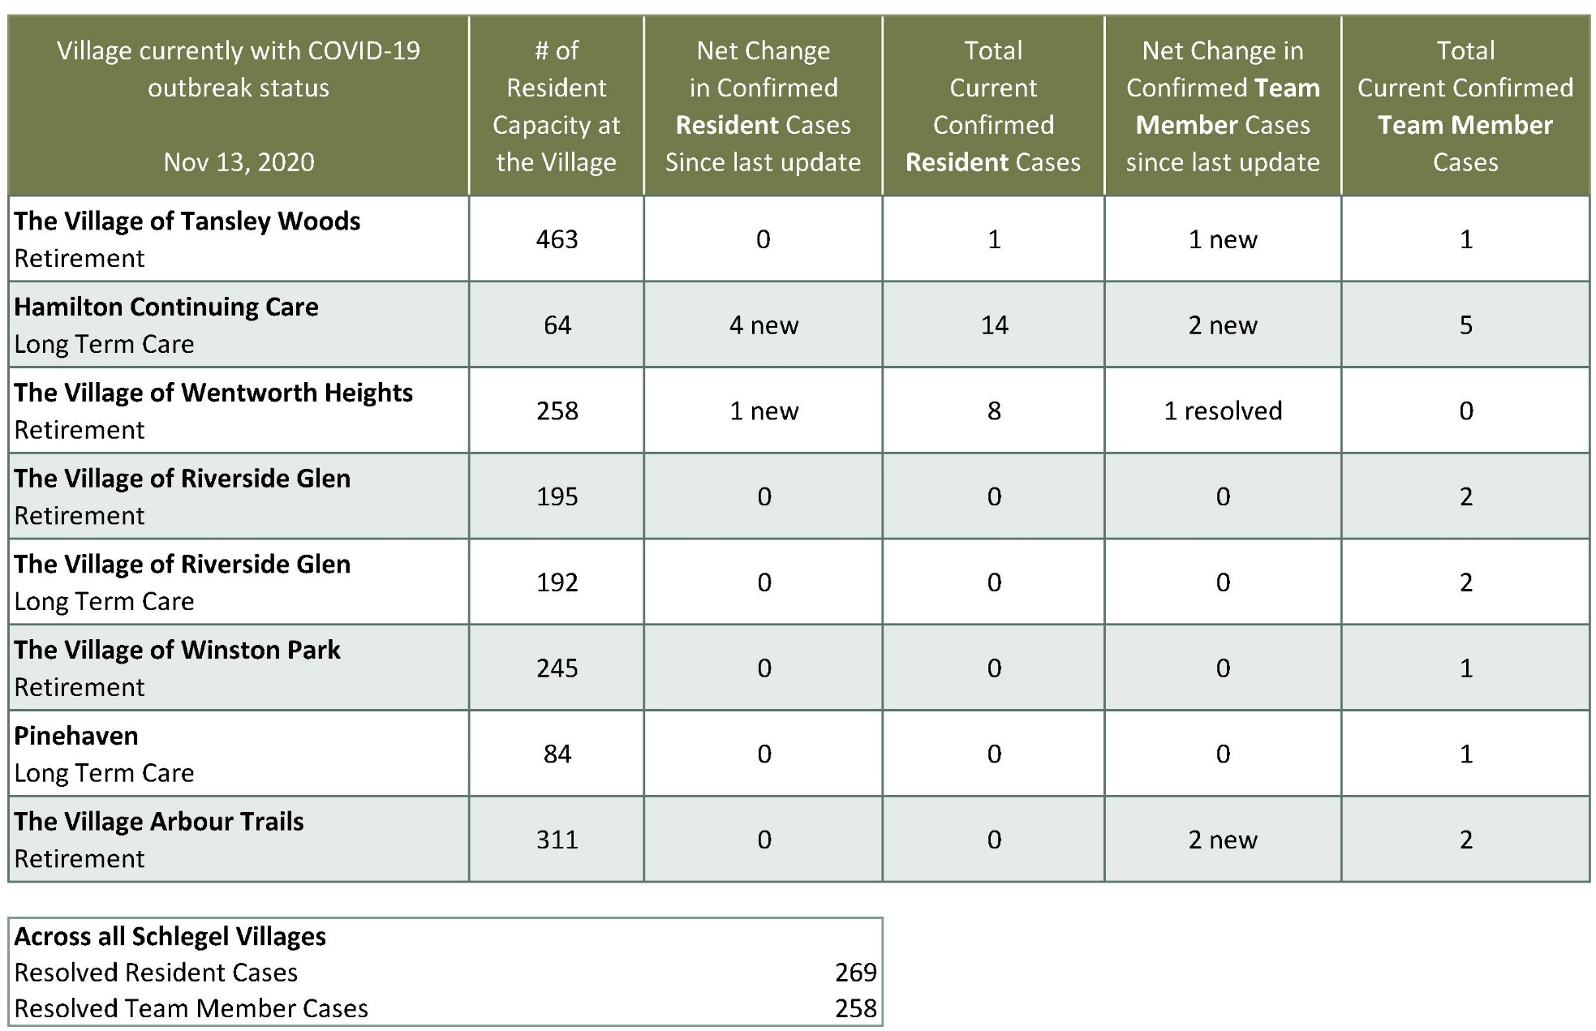
*The number in the first column of the chart represents the full capacity of each Village in terms of resident numbers.

